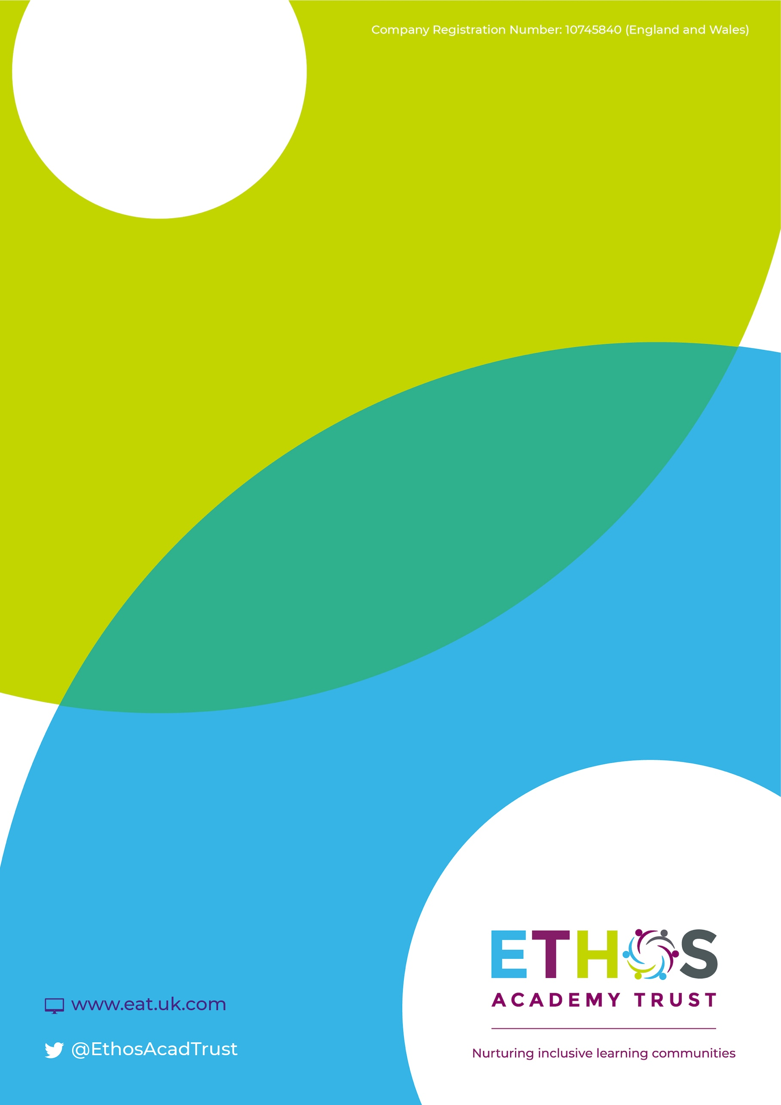

Ethos Academy Trust

Training Request Form

January 2021

Training Request Form

Please complete and return this form to training@eat.uk.com

Course Details
Course name: | Click here to enter text. | Course Venue: Click here to enter text.
Course date: | Click here to enter a date.
Course fees: | Click here to enter text.

Delegate Details
School name: | Click here to enter text.
Address: | Click here to enter text. | Postcode: | Click here to enter text.
 |  | Tel: | Click here to enter text.
PO number: | Click here to enter text.
Finance email:  (for billing purposes) | Click here to enter text.
Delegate name (s): | Click here to enter text.
Delegate role in school: | Click here to enter text.

Declaration:
By signing below I accept the above booking terms and conditions. I confirm that I have the authority to make this booking and enter into a binding contract with Ethos Academy Trust.
Signed: |  | Date:

Ethos Academy Trust booking terms and conditions.

- Bookings must be received in writing, either via post or via email and places are given on a first come, first served basis.
- Full payment must be made at least 14 days before the commencement of the event. Cancellations before this time will receive a full refund. For cancellations between 7 and 14 days prior to the course, a 50% refund will be applied. Cancellations made less than 7 days before the course will receive no refund.
Ethos Academy Trust reserves the right to cancel a course at any time prior to its commencement. In this event a full refund will be made to all parties.

