

CEO WELCOME

Offsite Provision Manager

Dear Applicant,

Thank you for your interest in this vital new Offsite Provision Manager post at Ethos Academy Trust. We hope that the information contained within this pack provides sufficient information and helps you to decide if you have the right qualities, skills and experience to apply for this position.

The overarching aim of Ethos Academy Trust is to create academies that provide environments that are welcoming, caring, calm, safe and purposeful and that, within a nurturing ethos, stretch our learners academically, support them pastorally and develop them socially and emotionally.

We seek to explore and celebrate the qualities that make our pupils unique. We believe passionately that education, at every stage of the pupil journey, is about the development and nurture of the whole child. We aspire for all our pupils to become confident, happy and caring individuals who achieve personal success and develop a love of learning and of life.

We already have four academies within the Trust and we are delighted to have opened the brand new Elements Academy in Rotherham in September 2022.

Thank you for your interest in Ethos Academy Trust.

Jayne Foster

CEO, Ethos Academy Trust

EXECUTIVE HEAD / HEAD TEACHER WELCOME

Dear Applicant

Elements Academy is a new special school which opened in September 2022 in Rotherham, South Yorkshire. It will offer 135 places for Key Stage 2 – 4 pupils (aged 7-16) who have an Education, Health and Care Plan (EHCP) where Social, Emotional and Mental Health (SEMH) is identified as the primary need.

Ethos Academy Trust has a long-standing reputation for achieving outstanding outcomes with vulnerable pupils. Our nurture-based philosophy underpins our practice. At Elements Academy, we will provide a caring, stimulating, safe and welcoming environment where learning is enjoyable, and teaching is personalised to the needs and interests of individuals. Pupils will be supported to fulfil their academic potential whilst developing the long-term confidence and skills required to succeed in post-16 education, employment or training.

Our outstanding staff teams are skilled at working with young people with needs across the SEMH range. In partnership with parents, carers and other professionals, we will take a holistic approach to ensuring a young person’s needs are identified and met throughout their journey at Elements Academy, preparing them for the next stage of their lives.

At Elements Academy, you will find strong, hardworking and dedicated members of staff. We believe in investing in our staff team and all staff have the opportunity to access high quality internal and external professional development. Working within Ethos Academy Trust is extremely rewarding; making a difference to vulnerable children and young people, knowing that the work you do has a genuine, long-term impact on a young person’s education and life chances.

We are seeking to appoint an Offsite Provision Manager to join our new team. The successful applicant must be dedicated to supporting our young people to reach their full potential. We would like to thank you for your interest in Elements Academy and we look forward to receiving your application.



Rebecca Smith Vicky Woodrow

Executive Head Teacher Head Teacher

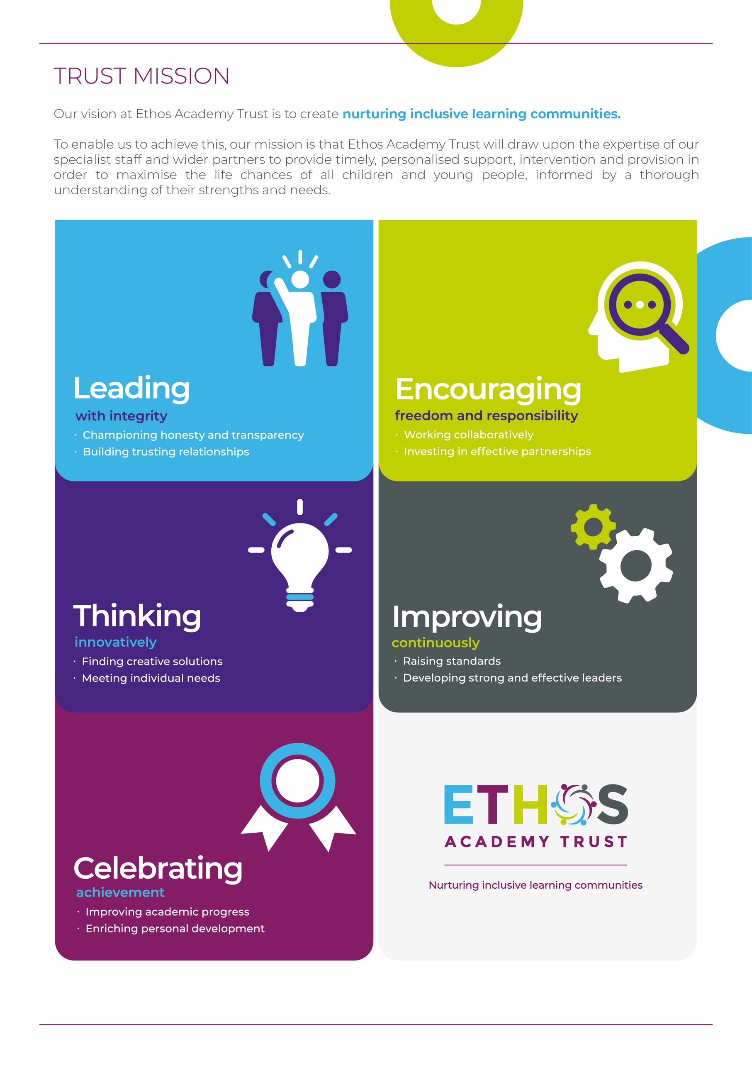

WHY WORK FOR THE TRUST?

Ethos Academy Trust is currently based in West and South Yorkshire with all of our Academies in close proximity to one another and in easy reach of main motorways and the cities and towns of Leeds, Wakefield, Sheffield, Rotherham, Huddersfield and Bradford. The proximity of our Academies is such that it lends itself to close and collaborative working.

At Ethos Academy Trust, we are committed to providing a top-class education and we put the needs of all of the young people within our community at the heart of what we do. Our staff are pivotal in this and also in recognising, achieving and bringing to life our vision and values.

As such, we are committed to providing our staff with high quality professional development which can be evidenced through a variety of channels. We have numerous examples of staff who have developed and progressed their careers with the Trust. We fully embrace the fact that if we invest in our staff and their futures, we will create an environment where staff are happy, inspired and ambitious, which in turn means that they are able to create positive, engaging and life changing learning experiences for young people.

Ethos Academy Trust is fully committed to supporting and enhancing the wellbeing and mental health of all stakeholders. Across the Trust there are regular opportunities for staff to come together outside of their normal working day in a social or other activity capacity.

As an employer, we are able to provide the following benefits to all members of staff:

* The Trust maintains nationally agreed terms and conditions in relation to pay and conditions for teaching and support staff, and continues to subscribe to local holiday patterns and allowances within the local authority of each academy.
* All employees have the opportunity to access a pension scheme.
* All employees have access to Healthline which includes 24/7 Employee Assistance Programme and services such as physio and counselling for employees and their dependants.
* An opportunity to collaborate with colleagues across academies and within the central Trust teams, with other academies and Multi Academy Trusts on a local or regional basis.
* Structured and informal opportunities to develop skills and opportunity to progress, share best practice (locally and nationally).
* Access to employee salary sacrifice schemes such as Cyclescheme, Techscheme and discounted gift cards.







ADVERT FOR OFFSITE PROVISION MANAGER

Grade/Salary: Band H, £29,174 - £30,984 (per annum, pro rata)

Hours: 37 hours per week, permanent, term-time only plus 5 days

Applicants

Do you want to make a real difference in the lives of vulnerable pupils? Do you want to work in an inclusive, nurturing school? Do you want to be part of a Trust that supports career progression? If so, this is an exciting opportunity to join Elements Academy, our brand new special school for children with social, emotional and mental health needs in Rotherham (S25).

We are looking for an Offsite Provision Manager who will be based at Elevate, Elements Academy which, on behalf of the local authority, provides education to students with Social, Emotional, Mental Health (SEMH) needs that impact on their ability to fully engage in and benefit from full time education. As a leading member of the offsite provision team, you will manage the timetables of all staff and act as first point of contact for professionals, whilst liaising with senior leaders to ensure the smooth running of the provision. A proportion of your time will be spend delivering sessions to pupils and supporting them to develop their academic ability and knowledge, whilst also supporting in the delivery of the personal development and SEMH curriculum.

You will possess GCSEs (A*-C) in Maths and English (or equivalent) or be able to demonstrate equivalent knowledge. It is desirable that you have knowledge of the national curriculum (applicable to a range of key stages) and a higher-level qualification. You will have experience of working with children/young people with SEMH needs within a school environment.

We are ambitious for growth and the development of our staff members and pupils and as such, there will be opportunities for progression within the Trust for successful candidates.

In return, we are able to offer a welcoming Trust with supportive management and a strong programme of staff development. You will receive exceptional support through our outstanding staff teams who are skilled at working with young people with needs across the SEMH range.

If you have any questions about the role, please contact our recruitment team at [recruitment@eat.uk.com](mailto:recruitment@eat.uk.com). You can also visit <https://www.eat.uk.com/about-ethos/a-day-in-the-life/> for a day in the life of working at Ethos.

About Ethos Academy Trust

Ethos Academy Trust is located within Kirklees and Wakefield, West Yorkshire, expanding in September 2022 into Rotherham, South Yorkshire. The overarching aim of the Trust is to create academies that provide environments that are welcoming, caring, calm, safe and purposeful and that, within a nurturing ethos, stretch our learners academically, support them pastorally and develop them socially and emotionally.

We seek to explore and celebrate the qualities that make our pupils unique. We believe passionately that education, at every stage of the pupil journey, is about the development and nurture of the whole child. We aspire for all our pupils to become confident, happy and caring individuals who achieve personal success and develop a love of learning and of life.

In addition to our five academies (Ethos College, Reach Academy, Engage Academy, Evolve Academy and Elements Academy), the Trust provides wide ranging early intervention outreach support and training to mainstream schools, alongside managing the statutory exclusions process on behalf of Kirklees Local Authority.

You can apply for the vacancy at <https://www.eat.uk.com/recruitment-portal/current-opportunities/>

**How to apply:**

**To apply, please sign in and apply via the purple button below.**

**Closing date:** 9am on 30th September 2022

**Interview dates:** 5th October 2022

OFFSITE PROVISION MANAGER

JOB DESCRIPTION

|  |  |
| --- | --- |
| **Job title** | Offsite Provision Manager |
| **Location** | Elevate at Elements Academy |
| **Hours** | 37 hours per week, permanent, term time only plus 5 days |
| **Reports to** | Headteacher |
| **Staff responsible for** | A team of staff |
| **Closing Date** | 9am on 30th September 2022 |
| **Salary/Grade** | Band H, £29,174 - £30,984 (per annum, pro rata) |
| **Job Purpose** | Elevate at Elements Academy, on behalf of the local authority, provides education to students with Social, Emotional, Mental Health (SEMH) needs that impact on their ability to fully engage in and benefit from full time education. Elevate have a dedicated team of tutors, key workers and support staff, who deliver bespoke learning opportunities and provide pastoral support for children to develop skills to achieve good outcomes.  As a leading member of the offsite provision team, you will manage the timetables of all staff, act as first point of contact for professionals and liaise with senior leaders to ensure the smooth running of the offsite provision.  A proportion of your time will be spent delivering sessions to pupils, supporting them to develop their academic ability and knowledge, whilst also supporting in the delivery of the personal development and SEMH curriculum. As the Offsite Provision Manager, you will lead by example in delivering high quality sessions and liaise with tutors to ensure that pupils are delivered an outstanding person-centred curriculum with the opportunity to make progress.  A significant element of the role includes safeguarding, which is at the forefront of our work at Ethos Academy Trust, and you will be expected to undertake statutory training and comply with our policies and procedures. |

KEY OBJECTIVES AND ACCOUNTABILITIES

**Main Duties**

* To be compliant in executing Elements Academy’s responsibility, on behalf of the local authority, to provide education to students with Social, Emotional, Mental Health (SEMH) needs that impact on their ability to fully engage in and benefit from full time education.
* To provide a detailed termly report to Ethos Academy Trust and the Local Authority, in line with the requirements set out in the Service Level Agreement.
* Work alongside the SENDCo on the allocation of pupils through the EHCP consultation process.
* Organise and lead initial and regular review meetings with professionals and parents/carers to ensure a smooth transition and regular attendance and engagement is achieved; working alongside tutors to ensure the curriculum offer supports pupil aspirations.
* Liaise effectively with the pupil, parents/carers and professionals, understanding the needs of the child and ensuring the appropriate number of sessions are provided to meet their needs and maximise their outcomes and life chances. Regularly review the number of sessions with a view to increase provision, where appropriate.
* Carry out home visits and act as a point of contact for parents/carers, developing trusting relationships through regular contact and keeping parents/carers informed of their child’s progress.
* Work alongside external agencies and key professionals, such as Educational Psychologists, CAMHS, and Family Support Workers, to ensure pupils’ needs are being met and key information is shared in a timely and effective manner.
* Manage, organise and monitor the deployment of the offsite provision team; analysing staff capacity in line with the funding allocation and liaise with the SLT regarding staff resourcing.
* Oversee the completion of part time timetables in line with the local authority guidance.
* Manage the day to day running of the offsite team, including cover and re-deployment, and communicate regularly to ensure staff are kept informed of new initiatives and key developments whilst working peripatetically.
* Act as a role model; be confident and flexible in the delivery of academic, personal development and SEMH lessons, from a range of exam boards and specifications, to pupils across all key stages.
* Actively embrace the nurture principles of the academy into curriculum planning and delivery.
* Regularly track and monitor the progress of all pupils; ensuring tracking is inputted in a timely manner during data collections.
* Work to meet the needs of individual pupils, as stated in their Educational Health and Care Plans, to maximise outcomes and future life chances.
* Update pupil records on the academy’s MIS system and CPOMS and support colleagues to record accurate, objective reflections, where required.
* Promote positive pupil behaviour, dealing promptly with conduct and incidents in line with the academy’s behaviour policy; encouraging pupils to take responsibility for their own behaviour.
* Confidently model the use of de-escalation, intervention and positive handling in line with Team Teach, Emotion Coaching and Restorative practices in line with academy’s behaviour policy and pupils’ support plans.
* Liaise with the exams officer and tutors with regards to exam entries.
* Undertake line management responsibilities; supporting staff through induction and the appraisal processes.
* Undertake relevant CPD; including attending weekly staff meetings, and be involved in ongoing development reviews of skills and competencies to improve practice through involvement in observation, reflection, evaluation and discussion with colleagues.
* Promote and actively support the academy’s responsibilities towards safeguarding.  Safeguarding is about keeping people safe and protecting people from harm, neglect, abuse and injury.  It is about creating safe places, being vigilant and doing something about any concerns you might have.  Safeguarding relates to everyone who may be vulnerable, not just the very old and the very young.
* Adhere to the Academy’s policies and ensure they are applied consistently.
* Other duties and responsibilities of an equivalent nature are undertaken, as may be determined by the post holder's supervisor from time to time, in consultation with the post holder.

**General**

* Be aware of and support difference and ensure equal opportunities for all.
* Contribute to the overall ethos/work/aims of the Trust.
* Attend meetings within the Trust, at its academies and external events as required.
* Share expertise and skills with others.
* Participate in training and other learning activities and performance development as required.
* Work effectively and professionally with all stakeholders, promoting the Trust positively at all times.
* Recognise own strengths and areas of expertise and use these to advise and support colleagues.
* Maintain confidentiality always in respect of school-related matters and to prevent disclosure of confidential and sensitive information.
* Ensure strict confidentiality in all areas of work.
* All employees are required to uphold the values of democracy, rule of law, individual liberty and tolerance and have mutual respect for those with different faiths and beliefs (Prevent).
* Work and process personal and sensitive information in accordance with Data Protection Act 2018 including the General Data Protection Regulations (GDPR) 2018.
* Understand and comply with the statutory guidance regarding safeguarding of children, ensuring the safeguarding and promotion of children’s welfare at all times, reporting any concerns to the Designated Safeguarding Lead immediately.

PERSON SPECIFICATION

OFFSITE PROVISION MANAGER

|  |  |  |
| --- | --- | --- |
|  | **Key Criteria** | **Essential (E) / Desirable (D)** |
| **Knowledge, Education and Training** | GCSE grade A-C (or equivalent) in English and Maths or ability to demonstrate equivalent knowledge | **E** |
|  | Knowledge of the national curriculum applicable to a range of key stages | **D** |
| A higher-level qualification | **D** |
| **Relevant Experience** | Experience of working with children / young people with SEMH needs in a school environment | **E** |
| Experience of planning and delivery Personal Development sessions, across a range of key stages | **D** |
| Understanding and experience of learning programmes/interventions | **D** |
| Understanding of child development, learning and nurture principles | **D** |
| Understanding of statutory procedures and policies for school attendance and absence | **D** |
| Understanding of safeguarding issues and procedures | **E** |
| Recent experience and knowledge of supporting the learning across a range of key stages | **E** |
| Experience of working with families to improve outcomes for children / young people | **D** |
|  | Experience of working collaboratively with other professionals and agencies | **D** |
| **Aptitudes, Skills and Competencies** | Ability to plan and deliver class and one to one activities | **E** |
| Ability to communicate effectively with pupils, staff, and other professionals | **E** |
| Ability to relate to children and young people from diverse / social backgrounds | **E** |
| Ability to work as a team member | **E** |
| Ability to work with children exhibiting challenging behaviours | **E** |
| Ability to create and develop personalised packages of support to improve outcomes | **E** |
| Ability to engage and work effectively with hard to reach parents and key family members | **E** |
| Willingness to lead extra-curricular activities | **E** |
| Ability and willingness to drive a school minibus and take part in training | **E** |
| Ensure that the reward and monitoring systems are consistently used to ensure accurate recording | **E** |
| Ability to support the academic and social, emotional and mental health (SEMH) needs of pupils | **E** |
| **Any additional factors** | Motivated to work with pupils with a wide range of learning, social emotional and mental health needs | **E** |
| Act as a role model and representative of the Trust both internally and externally | **E** |
| The post holder may be required to work outside of normal school hours on occasion with due notice | **E** |
| Willingness to undergo an enhanced DBS check and sign up the DBS service on a yearly basis | **E** |
| Understanding of relevant policies/codes of practice and awareness of relevant legislation | **E** |
| Commitment to ongoing personal training and development | **E** |
| Full driving license with business insurance along with a willingness to transport pupils in own vehicle | **E** |

Safeguarding statement

Ethos Academy Trust is committed to safeguarding and promoting the welfare of children and applicants must be willing to undergo child protection screening appropriate to the post, including an Enhanced DBS check (including Children’s Barred List) and past employment references.

Applicants are required, before appointment to disclose any conviction, caution or binding over including ‘spent convictions’ under the Rehabilitation of Offenders Act 1974 (Exemptions) Order 1975.

Equality and Diversity statement

Ethos Academy Trust treats all applicants for employment in the same way regardless of age, disability, gender reassignment, marriage and civil partnership, pregnancy and maternity, race, religion or belief, sex or sexual orientation.

Disability statement

Ethos Academy Trust is committed to promoting equality of opportunity for people with disabilities. We continue to review our processes and procedures to ensure individuals with disabilities receive full and fair consideration for all types of vacancies at the recruitment stage and during their employment.

Individuals who apply to the Trust for employment will receive fair treatment and be considered solely on their ability to do the job.  Where required reasonable adjustments will be applied. During employment the Trust, wherever possible, will retain the services of an employee who is or has become disabled.

GDPR

A copy of our Privacy Notice is available via our website.

**www.eat.co.uk**

