

CEO WELCOME

Learning Support Mentors

Dear Applicant,

Thank you for your interest in these vital new Learning Support Mentor posts at Ethos Academy Trust. We hope that the information contained within this pack provides sufficient information and helps you to decide if you have the right qualities, skills and experience to apply for these positions.

The overarching aim of Ethos Academy Trust is to create academies that provide environments that are welcoming, caring, calm, safe and purposeful and that, within a nurturing ethos, stretch our learners academically, support them pastorally and develop them socially and emotionally.

We seek to explore and celebrate the qualities that make our pupils unique. We believe passionately that education, at every stage of the pupil journey, is about the development and nurture of the whole child. We aspire for all our pupils to become confident, happy and caring individuals who achieve personal success and develop a love of learning and of life.

We already have four academies within the Trust and we are delighted to have opened the brand new Elements Academy in Rotherham in September 2022.

Thank you for your interest in Ethos Academy Trust.

Jayne Foster

CEO, Ethos Academy Trust

EXECUTIVE HEAD / HEAD TEACHER WELCOME

Dear Applicant

Elements Academy is a new special school which opened in September 2022 in Rotherham, South Yorkshire. It will offer 135 places for Key Stage 2 – 4 pupils (aged 7-16) who have an Education, Health and Care Plan (EHCP) where Social, Emotional and Mental Health (SEMH) is identified as the primary need.

Ethos Academy Trust has a long-standing reputation for achieving outstanding outcomes with vulnerable pupils. Our nurture-based philosophy underpins our practice. At Elements Academy, we will provide a caring, stimulating, safe and welcoming environment where learning is enjoyable, and teaching is personalised to the needs and interests of individuals. Pupils will be supported to fulfil their academic potential whilst developing the long-term confidence and skills required to succeed in post-16 education, employment or training.

Our outstanding staff teams are skilled at working with young people with needs across the SEMH range. In partnership with parents, carers and other professionals, we will take a holistic approach to ensuring a young person’s needs are identified and met throughout their journey at Elements Academy, preparing them for the next stage of their lives.

At Elements Academy, you will find strong, hardworking and dedicated members of staff. We believe in investing in our staff team and all staff have the opportunity to access high quality internal and external professional development. Working within Ethos Academy Trust is extremely rewarding; making a difference to vulnerable children and young people, knowing that the work you do has a genuine, long-term impact on a young person’s education and life chances.

We are seeking to appoint Learning Support Mentors to join our new team. The successful applicants must be dedicated to supporting our young people to reach their full potential. We would like to thank you for your interest in Elements Academy and we look forward to receiving your application.

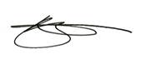

Rebecca Smith Vicky Woodrow

Executive Head Teacher Head Teacher

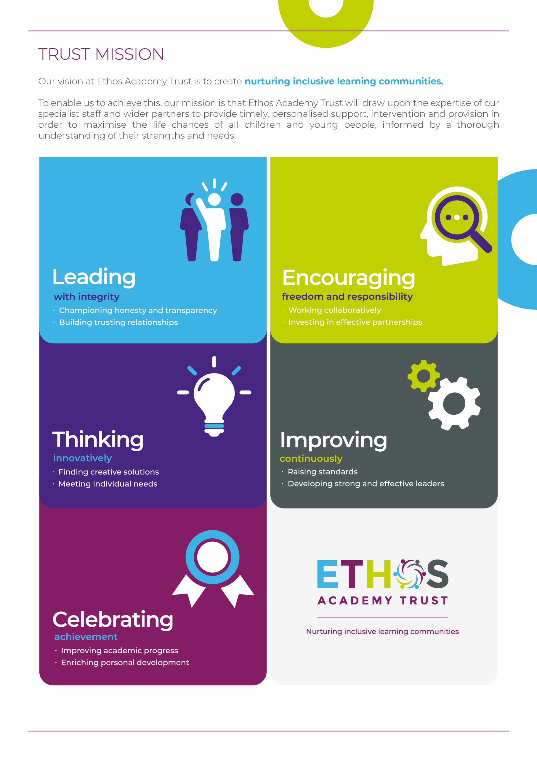

WHY WORK FOR THE TRUST?

Ethos Academy Trust is currently based in West and South Yorkshire with all of our Academies in close proximity to one another and in easy reach of main motorways and the cities and towns of Leeds, Wakefield, Sheffield, Rotherham, Huddersfield and Bradford. The proximity of our Academies is such that it lends itself to close and collaborative working.

At Ethos Academy Trust, we are committed to providing a top-class education and we put the needs of all of the young people within our community at the heart of what we do. Our staff are pivotal in this and also in recognising, achieving and bringing to life our vision and values.

As such, we are committed to providing our staff with high quality professional development which can be evidenced through a variety of channels. We have numerous examples of staff who have developed and progressed their careers with the Trust. We fully embrace the fact that if we invest in our staff and their futures, we will create an environment where staff are happy, inspired and ambitious, which in turn means that they are able to create positive, engaging and life changing learning experiences for young people.

Ethos Academy Trust is fully committed to supporting and enhancing the wellbeing and mental health of all stakeholders. Across the Trust there are regular opportunities for staff to come together outside of their normal working day in a social or other activity capacity.

As an employer, we are able to provide the following benefits to all members of staff:

* The Trust maintains nationally agreed terms and conditions in relation to pay and conditions for teaching and support staff, and continues to subscribe to local holiday patterns and allowances within the local authority of each academy.
* All employees have the opportunity to access a pension scheme.
* All employees have access to Healthline which includes 24/7 Employee Assistance Programme and services such as physio and counselling for employees and their dependants.
* An opportunity to collaborate with colleagues across academies and within the central Trust teams, with other academies and Multi Academy Trusts on a local or regional basis.
* Structured and informal opportunities to develop skills and opportunity to progress, share best practice (locally and nationally).
* Access to employee salary sacrifice schemes such as Cyclescheme, Techscheme and discounted gift cards.



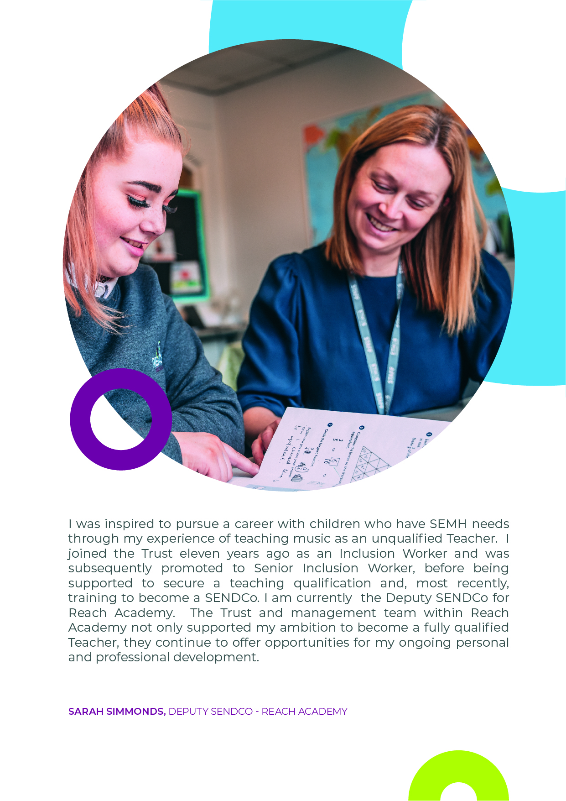

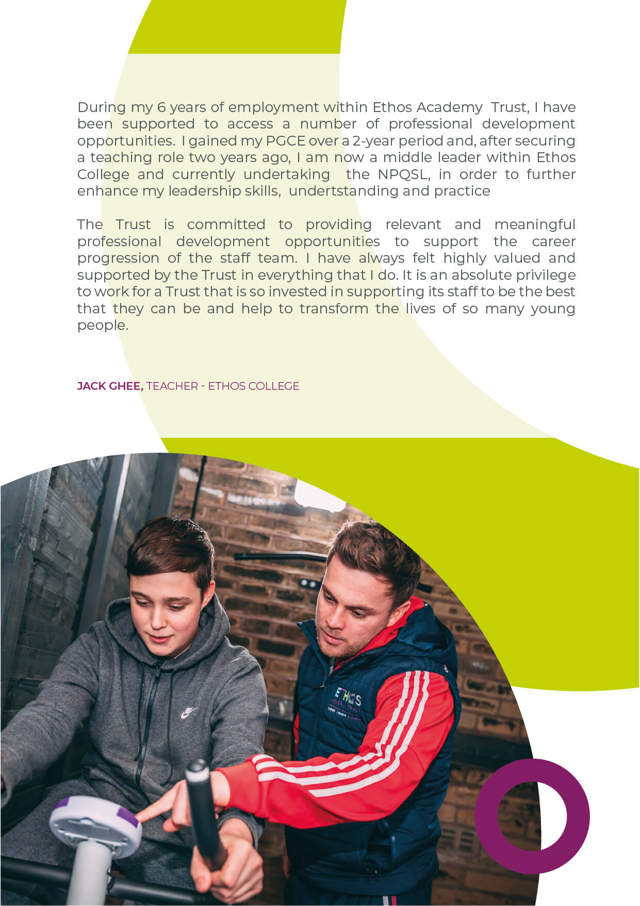

ADVERT FOR LEARNING SUPPORT MENTORS

Grade/Salary: Band F, £22,571 - £24,920 (per annum, pro rata) **-** Actual salary £19,793 -

£21,853 per annum

Hours: Full time, 39 weeks

Applicants

Do you want to make a real difference in the lives of vulnerable pupils? Do you want to work in an inclusive, nurturing school? Do you want to be part of a Trust that supports career progression? If so, this is an exciting opportunity to join Elements Academy, our brand new special school for children with social, emotional and mental health needs in Rotherham (S25).

We are looking for Learning Support Mentors who will provide positive, aspirational outcomes for pupils with complex social, emotional and mental health (SEMH) needs through high quality support and engagement supporting academic learning and securing pupils' physical, emotional wellbeing, whilst raising their self-esteem and encouraging independence. To complement the professional work of teachers by taking responsibility for agreed learning activities under the agreed system of supervision.

You will be qualified to NVQ Level 2 or equivalent in English and Maths (or have proven numeracy and literacy skills to level 2.) You must be able to meet the Higher Level Teaching Assistant standards, or have an equivalent qualification or experience. You will possess experience of working with children and have the ability to relate well to children and adults, coupled with training in the relevant learning strategies.

Our Learning Support Mentor positions present an excellent opportunity for candidates who are potentially looking to gain experience to progress into teaching or for those who aspire to work within the area of Social and Emotional Mental Health. We are ambitious for growth and the development of our staff members and pupils and as such, there will be opportunities for progression within the Trust for successful candidates.

In return, we are able to offer a welcoming Trust with supportive management and a strong programme of staff development. You will receive exceptional support through our outstanding staff teams who are skilled at working with young people with needs across the SEMH range.

If you have any questions about the role, please contact our recruitment team at [recruitment@eat.uk.com](mailto:recruitment@eat.uk.com). You can also visit <https://www.eat.uk.com/about-ethos/a-day-in-the-life/> for a day in the life of working at Ethos.

About Ethos Academy Trust

Ethos Academy Trust is located within Kirklees and Wakefield, West Yorkshire and expanded in September 2022 into Rotherham, South Yorkshire. The overarching aim of the Trust is to create academies that provide environments that are welcoming, caring, calm, safe and purposeful and that, within a nurturing ethos, stretch our learners academically, support them pastorally and develop them socially and emotionally.

We seek to explore and celebrate the qualities that make our pupils unique. We believe passionately that education, at every stage of the pupil journey, is about the development and nurture of the whole child. We aspire for all our pupils to become confident, happy and caring individuals who achieve personal success and develop a love of learning and of life.

In addition to our five academies (Ethos College, Reach Academy, Engage Academy, Evolve Academy and Elements Academy), the Trust provides wide ranging early i**ntervention outreach support and training to mainstream schools, alongside managing the statutory exclusions process on behalf of Kirklees Local Authority.**

You can apply for the vacancy at <https://www.eat.uk.com/recruitment-opportunities/learning-support-mentor-2/>

**Closing date:** 9am on 31st October 2022

**Interview dates:** W/C 7th November (provisional)

***Please note that as this is a new recruitment round, previous applicants will not be re-considered.***

LEARNING SUPPORT MENTOR

JOB DESCRIPTION

|  |  |
| --- | --- |
| **Job title** | Learning Support Mentor |
| **Location** | Elements Academy |
| **Hours** | Full-time, 39 weeks |
| **Reports to** | Primary Lead |
| **Staff responsible for** | N/A |
| **Closing Date** | 9am on 31st October 2022 |
| **Salary/Grade** | Band F, £22,571 - £24,920 (pro rata)  Actual salary £19,793 - £21,853 per annum |
| **Job Purpose** | The role will focus on providing positive, aspirational outcomes for pupils with complex social, emotional and mental health (SEMH) needs through high quality support and engagement supporting academic learning and securing pupils' physical, emotional wellbeing, whilst raising their self-esteem and encouraging independence.  To complement the professional work of teachers by taking responsibility for agreed learning activities under the agreed system of supervision. |

KEY OBJECTIVES AND ACCOUNTABILITIES

* To assess the need of pupils and use detailed knowledge and specialist skills to support pupils’ learning and SEMH development.
* To establish productive working relationships with pupils, acting as a role model and setting high expectations.
* To work with students through Intervention sessions as required.
* To develop and implement personalised plans for pupils based on individual need, in line with Education Health and Care Plans.
* To work with specific students through catch up sessions and extra-curricular activities.
* To develop trusting relationships with parents/carers, liaising regularly to share information.
* To promote the inclusion and acceptance of all pupils within the classroom.
* To support pupils consistently whilst recognising and responding to their individual needs.
* To encourage pupils to interact and work cooperatively with others and engage all pupils in activities.
* To promote independence and employ strategies to recognise and reward achievement of self-reliance.
* Update pupil records, using the MIS system and CPOMS, to record accurate objective accounts.
* To provide feedback to pupils in relation to SEMH progress and achievement.
* To organise and manage an appropriate learning environment and resources.
* Within an agreed system of supervision, plan and deliver challenging teaching and learning and SEMH objectives to evaluate and adjust lessons/work plans as appropriate.
* To monitor and evaluate pupils’ responses to learning activities through a range of assessments and monitoring strategies against predetermined learning and SEMH objectives.
* To provide objective and accurate feedback and reports, as required, to the teacher/SLT on pupil achievement, progress and other matters.
* To record progress and achievement in lessons/activities systematically and provide evidence on a range and level of progress and attainment.
* To promote positive pupil behaviour, maintaining high expectations for all pupils, using effective strategies to support pupil behaviour promoting self-control and independence.
* To support the role of parents and pupils’ learning and where appropriate, to lead meetings with parents and/or external agencies to provide constructive feedback on pupil progress/achievement etc, completing relevant associated documentation.
* To administer and invigilate exams/tests.
* To produce intervention lesson plans, resources etc.
* To advise on the appropriate deployment and use of specialist aid/resources/equipment.
* To deliver and supervise out of school learning activities within the guidelines established by the academy.
* To contribute to the identification and execution of appropriate out of school learning activities, which consolidate and extend work carried out in class.
* Other duties and responsibilities of an equivalent nature are undertaken, as may be determined by the post holder's supervisor from time to time, in consultation with the post holder.

**General**

* The postholder will be required to be able to meet the Higher Level Teaching Assistant standards or have equivalent qualification of experience.
* To be familiar and comply with all relevant legislation, policies and procedures including those relating to:- Health and Safety, Management of Risk, Data Protection, Standing Orders and Financial Regulations and Child Protection.
* To identify risks within personal objectives, using resources effectively and efficiently and safeguarding assets.
* To ensure equality of opportunity is afforded to all persons both internal and external to the Trust, actively seeking to eliminate any direct or indirect discriminatory practices/behaviour.

.

PERSON SPECIFICATION – LEARNING SUPPORT MENTOR

|  |  |  |
| --- | --- | --- |
|  | **Key Criteria** | **Essential (E) / Desirable (D)** |
| **Knowledge, Education and Training** | Higher Level Teaching Assistant standards must be met or equivalent qualification or experience. | **E** |
| NVQ 2 or equivalent in English and Maths, or proven numeracy and literacy skills to Level 2. | **E** |
| Training in the relevant learning strategies to support pupils with Special Educational Needs. | **E** |
| Good understanding of child development and learning processes. | **E** |
| Full working knowledge of relevant policies/codes of practice/legislation. | **E** |
| Understanding of statutory frameworks relating to education. | **E** |
| Understanding of classroom roles and responsibilities. | **E** |
| Knowledge and experience of using a range of computer applications & ICT to include word processing, spreadsheets, databases, presentation software, internet & e-mail. | **E** |
| Basic knowledge and understanding of Health and Safety issues, and ability to identify risks within personal sphere of work. | **E** |
| Appropriate First Aid training. | **D** |
| **Relevant Experience** | Experience of working with children. | **E** |
| **Aptitudes, Skills and Competencies** | Ability to relate well to adults and children. | **E** |
| The ability to with Trust priorities/policies in a joined up way with others internally and externally and to operates democratically, transparently and accountably. | **E** |
| The ability to motivate others to deliver their full potential and achieve goals. Demonstrating honesty and integrity.  Developing and selecting effective solutions to problems and proactively managing risk and change. | **E** |
| The ability to challenges the status quo and seek out best practice to achieve the Trust’s "Vision". Ensuring sustainable development. | **E** |
| Ability to deliver efficient and effective customer service to internal and external stakeholders. Engages and empowers stakeholders. Listens to the stakeholders and learns from experience. Committed to safeguarding and promoting the welfare of children and young people. | **E** |
| An understanding of equality and diversity and takes an equalities approach to managing own behaviour and the behaviour of others. Demonstrates fairness and is worthy of respect. | **E** |
| Works with others in a flexible and constructive way. Helps to generate an environment of trust and cooperation. | **E** |
| Communicating and engaging with others in an effective and persuasive manner. | **E** |
| **Any additional factors** | Commitment to ongoing personal training and development | **E** |
| Willingness to work outside of normal Trust hours on occasion | **E** |
| Hold current driving licence and have own vehicle available for transport during the working day | **D** |
| Willingness to undertake an enhanced Disclosure and Barring Service check, pre-employment and annually. Please note a conviction may not exclude candidates from employment but will be considered as part of the selection process | **E** |

Safeguarding statement

Ethos Academy Trust is committed to safeguarding and promoting the welfare of children and applicants must be willing to undergo child protection screening appropriate to the post, including an Enhanced DBS check (including Children’s Barred List) and past employment references.

Applicants are required, before appointment to disclose any conviction, caution or binding over including ‘spent convictions’ under the Rehabilitation of Offenders Act 1974 (Exemptions) Order 1975.

Equality and Diversity statement

Ethos Academy Trust treats all applicants for employment in the same way regardless of age, disability, gender reassignment, marriage and civil partnership, pregnancy and maternity, race, religion or belief, sex or sexual orientation.

Disability statement

Ethos Academy Trust is committed to promoting equality of opportunity for people with disabilities. We continue to review our processes and procedures to ensure individuals with disabilities receive full and fair consideration for all types of vacancies at the recruitment stage and during their employment.

Individuals who apply to the Trust for employment will receive fair treatment and be considered solely on their ability to do the job.  Where required reasonable adjustments will be applied. During employment the Trust, wherever possible, will retain the services of an employee who is or has become disabled.

GDPR

A copy of our Privacy Notice is available via our website.

**www.eat.co.uk**

