

CEO WELCOME

Teaching Assistants

Dear Applicant,

Thank you for your interest in these vital new Teaching Assistant posts at Ethos Academy Trust. We hope that the information contained within this pack provides sufficient information and helps you to decide if you have the right qualities, skills and experience to apply for these positions.

The overarching aim of Ethos Academy Trust is to create academies that provide environments that are welcoming, caring, calm, safe and purposeful and that, within a nurturing ethos, stretch our learners academically, support them pastorally and develop them socially and emotionally.

We seek to explore and celebrate the qualities that make our pupils unique. We believe passionately that education, at every stage of the pupil journey, is about the development and nurture of the whole child. We aspire for all our pupils to become confident, happy and caring individuals who achieve personal success and develop a love of learning and of life.

We already have four academies within the Trust and we are delighted to have opened the brand new Elements Academy in Rotherham in September 2022.

Thank you for your interest in Ethos Academy Trust.

Jayne Foster

CEO, Ethos Academy Trust

EXECUTIVE HEAD / HEAD TEACHER WELCOME

Dear Applicant

Elements Academy is a new special school which opened in September 2022 in Rotherham, South Yorkshire. It will offer 135 places for Key Stage 2 – 4 pupils (aged 7-16) who have an Education, Health and Care Plan (EHCP) where Social, Emotional and Mental Health (SEMH) is identified as the primary need.

Ethos Academy Trust has a long-standing reputation for achieving outstanding outcomes with vulnerable pupils. Our nurture-based philosophy underpins our practice. At Elements Academy, we will provide a caring, stimulating, safe and welcoming environment where learning is enjoyable, and teaching is personalised to the needs and interests of individuals. Pupils will be supported to fulfil their academic potential whilst developing the long-term confidence and skills required to succeed in post-16 education, employment or training.

Our outstanding staff teams are skilled at working with young people with needs across the SEMH range. In partnership with parents, carers and other professionals, we will take a holistic approach to ensuring a young person’s needs are identified and met throughout their journey at Elements Academy, preparing them for the next stage of their lives.

At Elements Academy, you will find strong, hardworking and dedicated members of staff. We believe in investing in our staff team and all staff have the opportunity to access high quality internal and external professional development. Working within Ethos Academy Trust is extremely rewarding; making a difference to vulnerable children and young people, knowing that the work you do has a genuine, long-term impact on a young person’s education and life chances.

We are seeking to appoint Teaching Assistants to join our new team. The successful applicants must be dedicated to supporting our young people to reach their full potential. We would like to thank you for your interest in Elements Academy and we look forward to receiving your application.

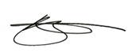

Rebecca Smith Vicky Woodrow

Executive Head Teacher Head Teacher

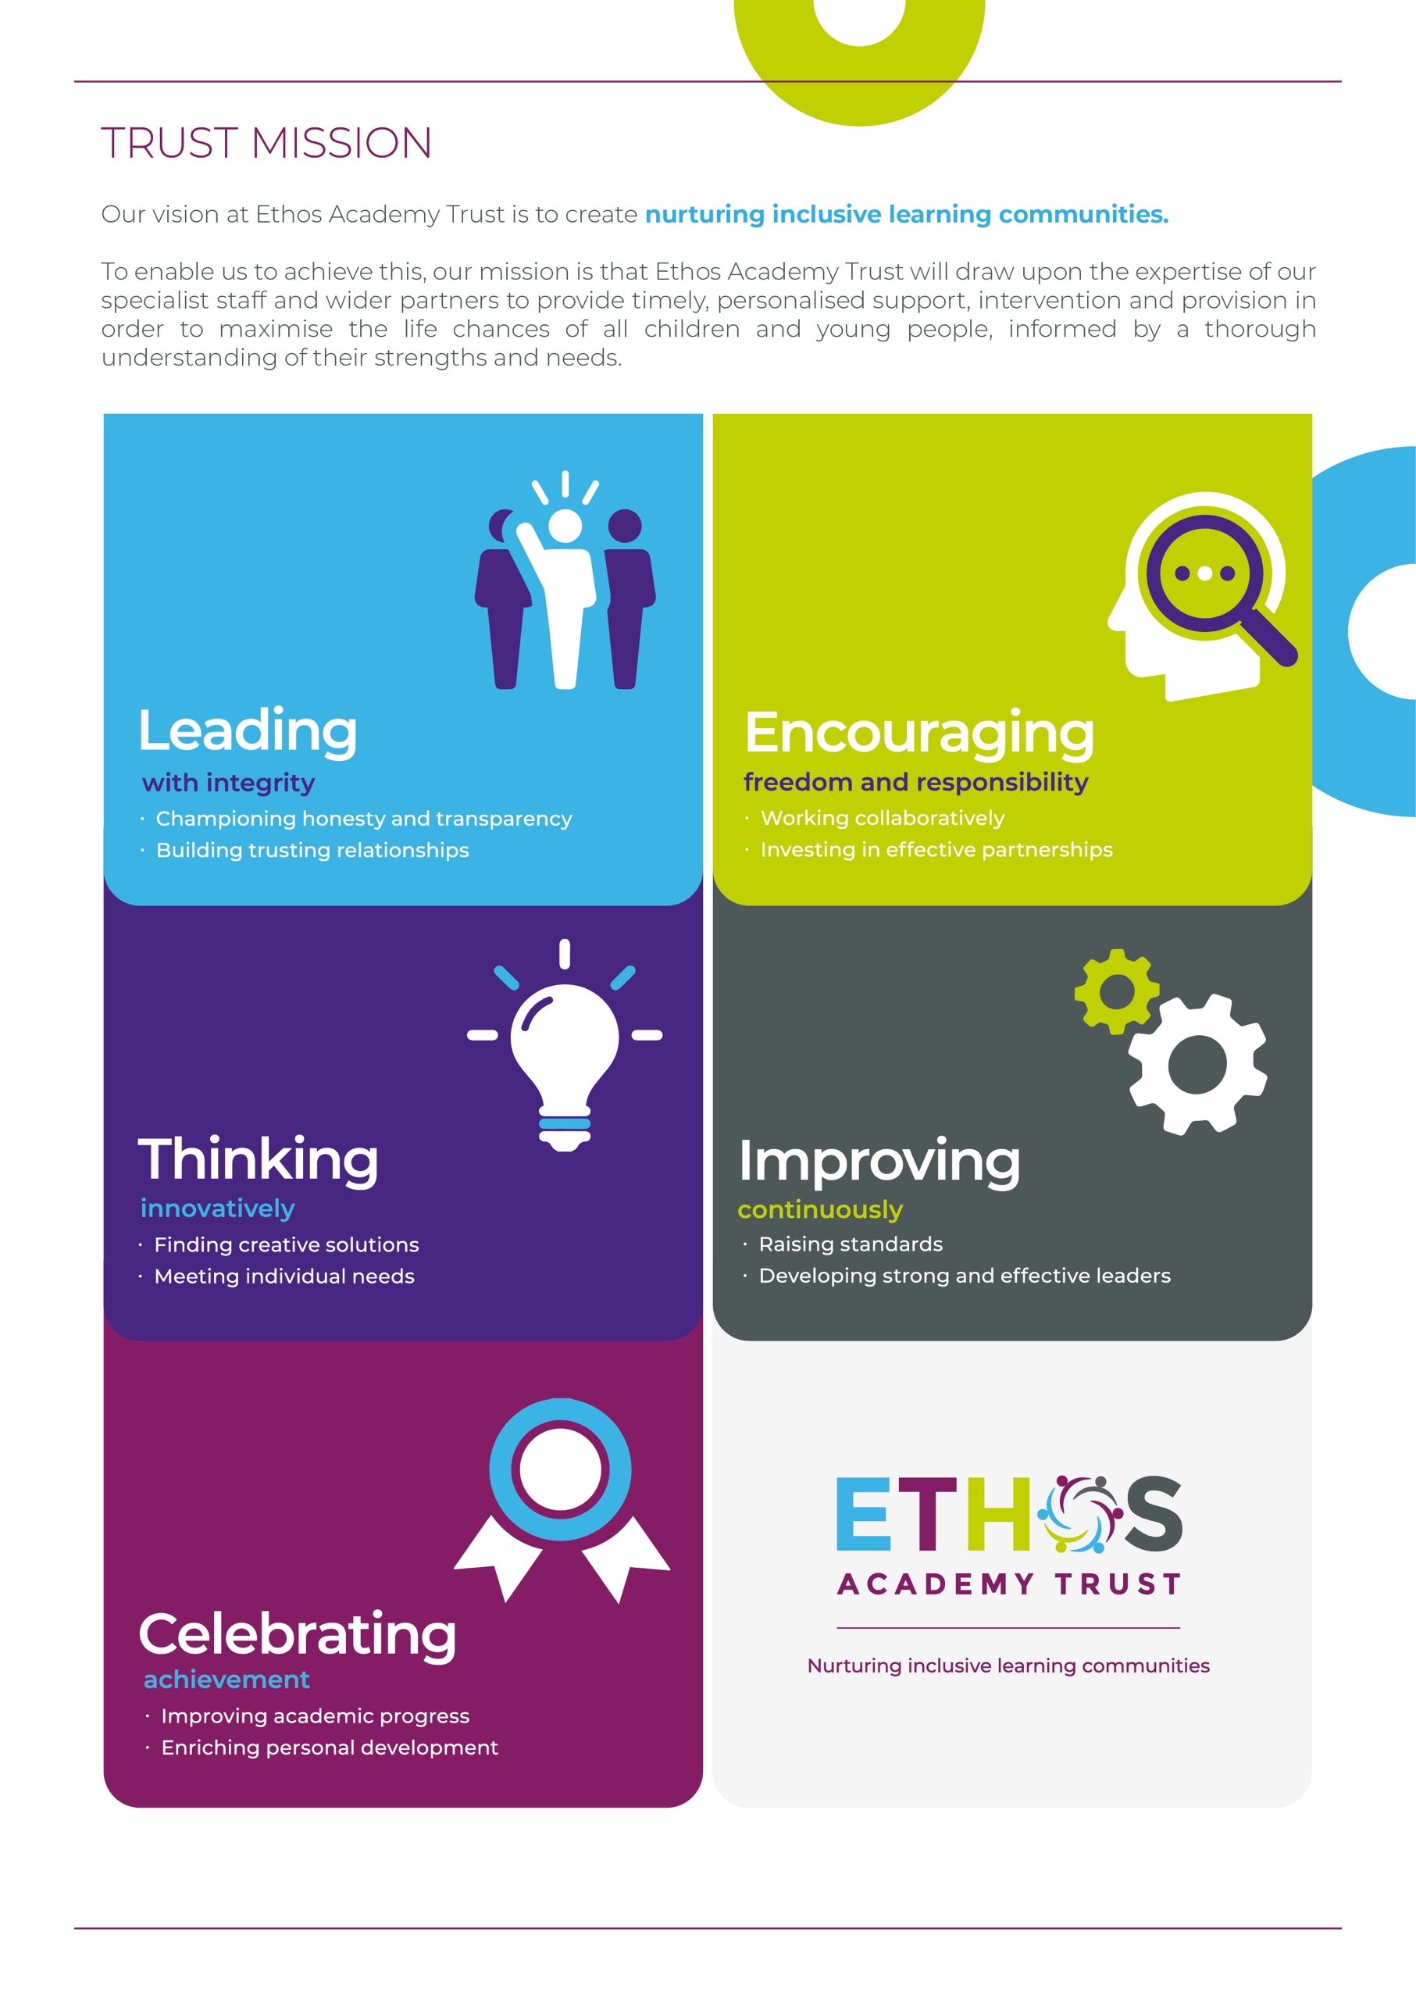

WHY WORK FOR THE TRUST?

Ethos Academy Trust is currently based in West and South Yorkshire with all of our Academies in close proximity to one another and in easy reach of main motorways and the cities and towns of Leeds, Wakefield, Sheffield, Rotherham, Huddersfield and Bradford. The proximity of our Academies is such that it lends itself to close and collaborative working.

At Ethos Academy Trust, we are committed to providing a top-class education and we put the needs of all of the young people within our community at the heart of what we do. Our staff are pivotal in this and also in recognising, achieving and bringing to life our vision and values.

As such, we are committed to providing our staff with high quality professional development which can be evidenced through a variety of channels. We have numerous examples of staff who have developed and progressed their careers with the Trust. We fully embrace the fact that if we invest in our staff and their futures, we will create an environment where staff are happy, inspired and ambitious, which in turn means that they are able to create positive, engaging and life changing learning experiences for young people.

Ethos Academy Trust is fully committed to supporting and enhancing the wellbeing and mental health of all stakeholders. Across the Trust there are regular opportunities for staff to come together outside of their normal working day in a social or other activity capacity.

As an employer, we are able to provide the following benefits to all members of staff:

* The Trust maintains nationally agreed terms and conditions in relation to pay and conditions for teaching and support staff, and continues to subscribe to local holiday patterns and allowances within the local authority of each academy.
* All employees have the opportunity to access a pension scheme.
* All employees have access to Healthline which includes 24/7 Employee Assistance Programme and services such as physio and counselling for employees and their dependants.
* An opportunity to collaborate with colleagues across academies and within the central Trust teams, with other academies and Multi Academy Trusts on a local or regional basis.
* Structured and informal opportunities to develop skills and opportunity to progress, share best practice (locally and nationally).
* Access to employee salary sacrifice schemes such as Cyclescheme, Techscheme and discounted gift cards.



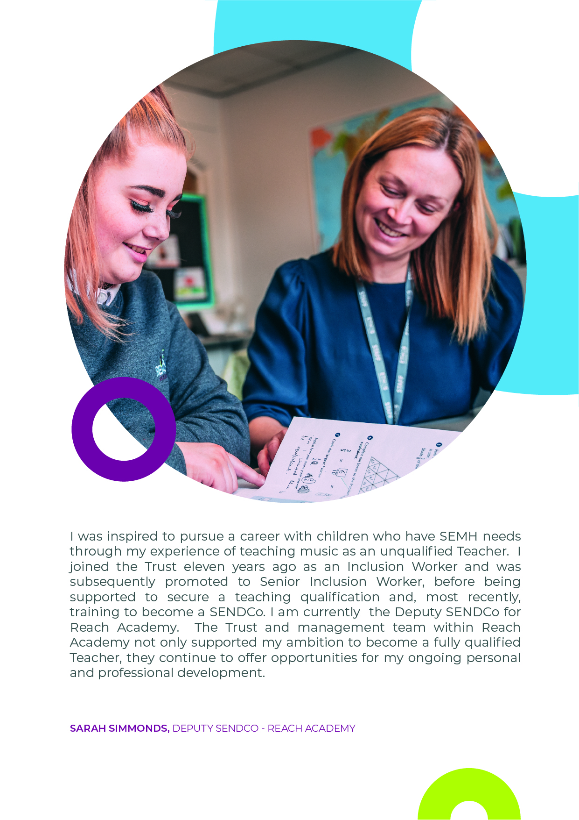

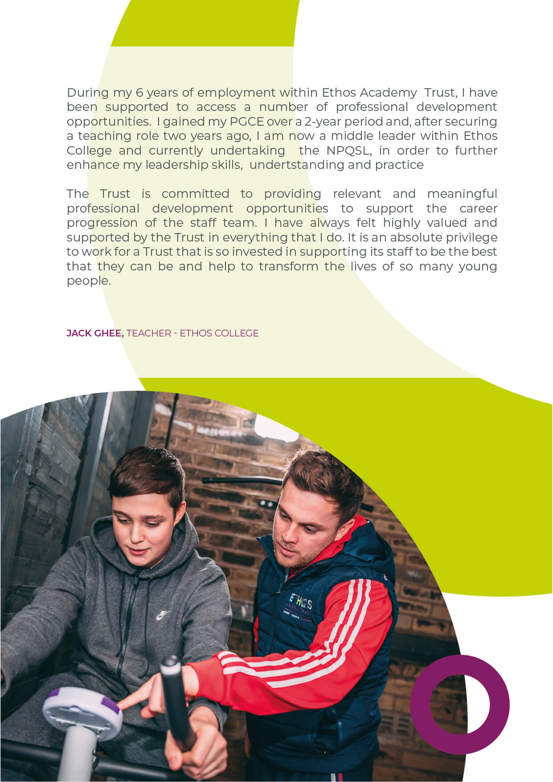

ADVERT FOR TEACHING ASSISTANTS

Grade/Salary: Band C, £19,264 (per annum, pro rata) **–** actual salary £15,979 per annum

Hours: Full time, 39 weeks.

**We have vacancies for Teaching Assistants who will work predominantly on a one-to-one basis with our pupils (fixed term contracts for up to twelve months, with the possibility of extension) and permanent Teaching Assistants who will work with groups of pupils. Please stipulate your preference for the available positions within the supporting statement of your application form.**

Applicants

Do you want to make a real difference in the lives of vulnerable pupils? Do you want to work in an inclusive, nurturing school? Do you want to be part of a Trust that supports career progression? If so, this is an exciting opportunity to join Elements Academy, our brand new special school for children with social, emotional and mental health needs in Rotherham (S25).

We are looking for Teaching Assistants who will predominantly work with a pupil on a one-to-one basis to provide positive and aspirational outcomes for a pupil with complex social, emotional and mental health (SEMH) needs through high quality support and engagement, supporting transition and securing their physical and emotional wellbeing, whilst raising their self-esteem and encouraging independence.

We are also looking for Teaching Assistants who will provide positive and aspirational outcomes for pupils with complex social, emotional and mental health (SEMH) needs through high quality support and engagement, supporting transition and securing their physical and emotional wellbeing, whilst raising their self-esteem and encouraging independence.

You will possess GCSEs (A*-C) in Maths and English (or equivalent) or alternatively, you will hold a relevant qualification at level 2 (or equivalent). It is desirable that you have experience of working with children with special educational needs in KS2, 3 or 4 with SEMH needs. In addition, you will be able to communicate information in a clear and logical manner and be proactive and positive in your approach.

Our Teaching Assistant positions present an excellent opportunity for candidates who are potentially looking to gain experience to progress into teaching or for those who aspire to work within the area of Social and Emotional Mental Health. We are ambitious for growth and the development of our staff members and pupils and as such, there will be opportunities for progression within the Trust for successful candidates.

In return, we are able to offer a welcoming Trust with supportive management and a strong programme of staff development. You will receive exceptional support through our outstanding staff teams who are skilled at working with young people with needs across the SEMH range.

If you have any questions about the role, please contact our recruitment team at [recruitment@eat.uk.com](mailto:recruitment@eat.uk.com). You can also visit <https://www.eat.uk.com/about-ethos/a-day-in-the-life/> for a day in the life of working at Ethos.

About Ethos Academy Trust

Ethos Academy Trust is located within Kirklees and Wakefield, West Yorkshire and expanded in September 2022 into Rotherham, South Yorkshire. The overarching aim of the Trust is to create academies that provide environments that are welcoming, caring, calm, safe and purposeful and that, within a nurturing ethos, stretch our learners academically, support them pastorally and develop them socially and emotionally.

We seek to explore and celebrate the qualities that make our pupils unique. We believe passionately that education, at every stage of the pupil journey, is about the development and nurture of the whole child. We aspire for all our pupils to become confident, happy and caring individuals who achieve personal success and develop a love of learning and of life.

In addition to our five academies (Ethos College, Reach Academy, Engage Academy, Evolve Academy and Elements Academy), the Trust provides wide ranging early intervention outreach support and training to mainstream schools, alongside managing the statutory exclusions process on behalf of Kirklees Local Authority.

You can apply for the vacancy at <https://www.eat.uk.com/recruitment-opportunities/4508/>

**Closing date:** 9am on 31st October 2022

**Interview dates:** W/C 7th November (provisional)

***Please note that as this is a new recruitment round, previous applicants will not be re-considered.***

TEACHING ASSISTANT

JOB DESCRIPTION

|  |  |
| --- | --- |
| **Job title** | Teaching Assistant |
| **Location** | Elements Academy |
| **Hours** | Full-time, 39 weeks.  Fixed term contracts for up to twelve months (with the possibility of extension) and permanent contracts are available |
| **Reports to** | Primary Lead |
| **Staff responsible for** | N/A |
| **Closing Date** | 9am on 31st October 2022 |
| **Salary/Grade** | Band C, £19,264 (per annum, pro rata) **–** actual salary £15,979 per annum |
| **Job Purpose** | **Teaching Assistants (permanent):** to provide positive and aspirational outcomes for pupils with complex social, emotional and mental health (SEMH) needs through high quality support and engagement, supporting transition and securing pupils' physical and emotional wellbeing, whilst raising their self-esteem and encouraging independence.  **Teaching Assistants (fixed-term contract):** working predominantly with one allocated pupil during their time at Elements Academy, to provide positive and aspirational outcomes for their complex social, emotional and mental health (SEMH) needs through high quality support and engagement, supporting transition and securing their physical and emotional wellbeing, whilst raising their self-esteem and encouraging independence. |

KEY OBJECTIVES AND ACCOUNTABILITIES

* To support pupils, (or one allocated pupil) across KS2-KS4.
* To establish supportive, caring and secure relationships with pupil(s), acting as a role model and responding appropriately to individual needs.
* To develop knowledge of a range of learning and SEMH needs and to plan, devise and implement appropriate programmes to support the development of children’s emotional literacy skills and emotional well-being.
* To implement and review intervention programmes/SEMH targets.
* To create, develop and produce resources for use with intervention programmes, as appropriate, to support SEMH development.
* To ensure that all pupil records are kept up to date on the relevant systems in accordance with the academy’s procedures, and that appropriate levels of confidentiality are maintained.
* To liaise, and maintain good working relationships with other staff, parents and external agencies, completing relevant associated paperwork.
* To contribute to monitoring and recording pupils’ SEMH progress and providing relevant feedback to stakeholders.
* To liaise with the class teachers and SENDCO in the identification and targeting of pupils’ SEND needs.
* To liaise with teachers in the preparation of personalised plans and subsequent reviews for identified children.
* To attend relevant in-service training as appropriate.
* To attend to the pupil’s personal needs and implement related personal programmes including educational, social, health, physical, hygiene, first aid and welfare matters.
* Supervise and support pupils, ensuring their safety and access to learning.
* Promote the inclusion and acceptance of all pupils.
* Encourage pupils to interact with others and engage in activities.
* Encourage pupils to act independently as appropriate.
* Prepare the classroom, as directed, for the day and clear afterwards and assist with the display of pupils’ work.
* Be aware of pupils’ individual needs, progress and achievements, and report to relevant staff.
* Use effective strategies to support and promote positive pupil behaviour.
* Provide clerical/admin support e.g. photocopying, filing.
* Support pupils to understand instructions.
* Provide academic support within the classroom, under the direction of the teacher.
* Support pupils in using ICT as directed.
* Prepare and maintain equipment/resources and assist pupils in their use.
* Contribute to the overall ethos/aims of the academy.
* Assist with the supervision of pupils out of lessons ie: break, lunchtime and taxi duty where required.
* Accompany teaching staff and pupils on visits, trips and out of school activities as required.
* Other duties and responsibilities of an equivalent nature are undertaken, as may be determined by the post holder's supervisor from time to time, in consultation with the post holder.

**General**

* To be familiar and comply with all relevant legislation, policies and procedures including those relating to:- Health and Safety, Management of Risk, Data Protection, Standing Orders and Financial Regulations and Child Protection.
* To identify risks within personal objectives, using resources effectively and efficiently and safeguarding assets.
* To ensure equality of opportunity is afforded to all persons both internal and external to the Trust, actively seeking to eliminate any direct or indirect discriminatory practices/behaviour.

PERSON SPECIFICATION

|  |  |  |
| --- | --- | --- |
|  | **Key Criteria** | **Essential (E) / Desirable (D)** |
| **Knowledge, Education and Training** | You will possess GCSEs (A*-C) in Maths and English or equivalent OR relevant qualification at level 2 (or equivalent). | **E** |
| Awareness of policies and procedures relating to child protection, health & safety and security, confidentiality and data protection. | **E** |
| Basic knowledge and understanding of Health and Safety issues, and ability to identify risks within personal sphere of work. | **E** |
| Basic knowledge of First Aid. | **E** |
| **Relevant Experience** | Experience of working with children, especially children with special needs in KS2, 3 or 4 (with SEMH experience). | **D** |
| **Aptitudes, Skills and Competencies** | Basic ICT skills. | **E** |
| Ability to make simple decisions, in line with agreed procedures/policies e.g. prioritisation of work, appropriate release of sensitive information. | **E** |
| Ability to clearly interpret oral or written information & instructions. | **E** |
| Ability to communicate information in a clear and logical manner. | **E** |
| Ability to maintain filing systems (manual and computerised). | **E** |
| Ability to use Microsoft Office and Management Information Systems. | **E** |
| Proactive and positive approach to liaising with parents/carers and wider stakeholders, both internally and externally. Committed to safeguarding and promoting the welfare of children and young people. | **E** |
| Plans own day, works flexibly to get the job done on time, and ensures work is carried out to quality standards. | **E** |
| Listens to others’ points of view, seeks feedback and deals with it constructively, shares knowledge and good practice, suggests doing things differently to improve. | **E** |
| Treats all people equally, fairly and with dignity and respect. | **E** |
| Positive approach to team working. | **E** |
| Takes ownership of personal development. Willing to pursue development opportunities. | **E** |
| **Any additional factors** | Commitment to ongoing personal training and development. | **E** |
| Willingness to work outside of normal Trust hours on occasion. | **E** |
| Hold current driving licence and have own vehicle available for transport during the working day. | D |
| Willingness to undertake an enhanced Disclosure and Barring Service check, pre-employment and annually. Please note a conviction may not exclude candidates from employment but will be considered as part of the selection process | E |

Safeguarding statement

Ethos Academy Trust is committed to safeguarding and promoting the welfare of children and applicants must be willing to undergo child protection screening appropriate to the post, including an Enhanced DBS check (including Children’s Barred List) and past employment references.

Applicants are required, before appointment to disclose any conviction, caution or binding over including ‘spent convictions’ under the Rehabilitation of Offenders Act 1974 (Exemptions) Order 1975.

Equality and Diversity statement

Ethos Academy Trust treats all applicants for employment in the same way regardless of age, disability, gender reassignment, marriage and civil partnership, pregnancy and maternity, race, religion or belief, sex or sexual orientation.

Disability statement

Ethos Academy Trust is committed to promoting equality of opportunity for people with disabilities. We continue to review our processes and procedures to ensure individuals with disabilities receive full and fair consideration for all types of vacancies at the recruitment stage and during their employment.

Individuals who apply to the Trust for employment will receive fair treatment and be considered solely on their ability to do the job.  Where required reasonable adjustments will be applied. During employment the Trust, wherever possible, will retain the services of an employee who is or has become disabled.

GDPR

A copy of our Privacy Notice is available via our website.

**www.eat.co.uk**

