CEO WELCOME
Inclusion Worker - Classroom Assistant

Dear Applicant,

Thank you for your interest in this vital new post of Inclusion Worker (Classroom Assistant) at Ethos Academy Trust. We hope that the information contained within this pack provides sufficient information and helps you to decide if you have the right qualities, skills and experience to apply for this position.

The overarching aim of Ethos Academy Trust is to create academies that provide environments that are welcoming, caring, calm, safe and purposeful and that, within a nurturing ethos, stretch our learners academically, support them pastorally and develop them socially and emotionally.

We seek to explore and celebrate the qualities that make our pupils unique. We believe passionately that education, at every stage of the pupil journey, is about the development and nurture of the whole child. We aspire for all our pupils to become confident, happy and caring individuals who achieve personal success and develop a love of learning and of life.

We currently have four academies (Ethos College, Reach Academy, Evolve Academy and Engage Academy) and we have high aspirations for future growth. In addition to the academies, the Trust provides wide ranging early intervention outreach support and training to mainstream schools, alongside managing the statutory exclusions process on behalf of Kirklees Local Authority.

Thank you for your interest in Ethos Academy Trust.

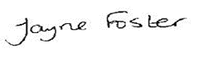
Jayne Foster
CEO, Ethos Academy Trust

HEADTEACHER WELCOME

Dear Applicant,

Reach Academy is a well-established pupil referral unit in Kirklees, specialising in supporting Key Stage 3 pupils with wide-ranging Social, Emotional and Mental Health (SEMH) needs.

At Reach Academy, we believe that all pupils deserve the opportunity to be supported to re-engage with learning and school life. We achieve this within a stimulating, safe and welcoming environment, where the curriculum is personalised to meet the differing needs and interests of all our pupils. Our staff pride themselves on offering a nurture-based approach and a high-quality educational provision that supports pupils to achieve positive outcomes and become ready to move onto further success in their next educational setting.

We are committed to ensuring that our staff are fully equipped to deliver a personalised, aspirational offer that meets the needs of all pupils. We therefore have a comprehensive staff training programme to enable our team to continue to develop their knowledge, skills and practice, with a high focus on supporting all aspects of SEMH needs.

Thank you for your interest in working at Reach Academy. Visits to the school are always welcome, so please do not hesitate to contact the main office for further information.

Hannah Lord
Head Teacher, Reach Academy

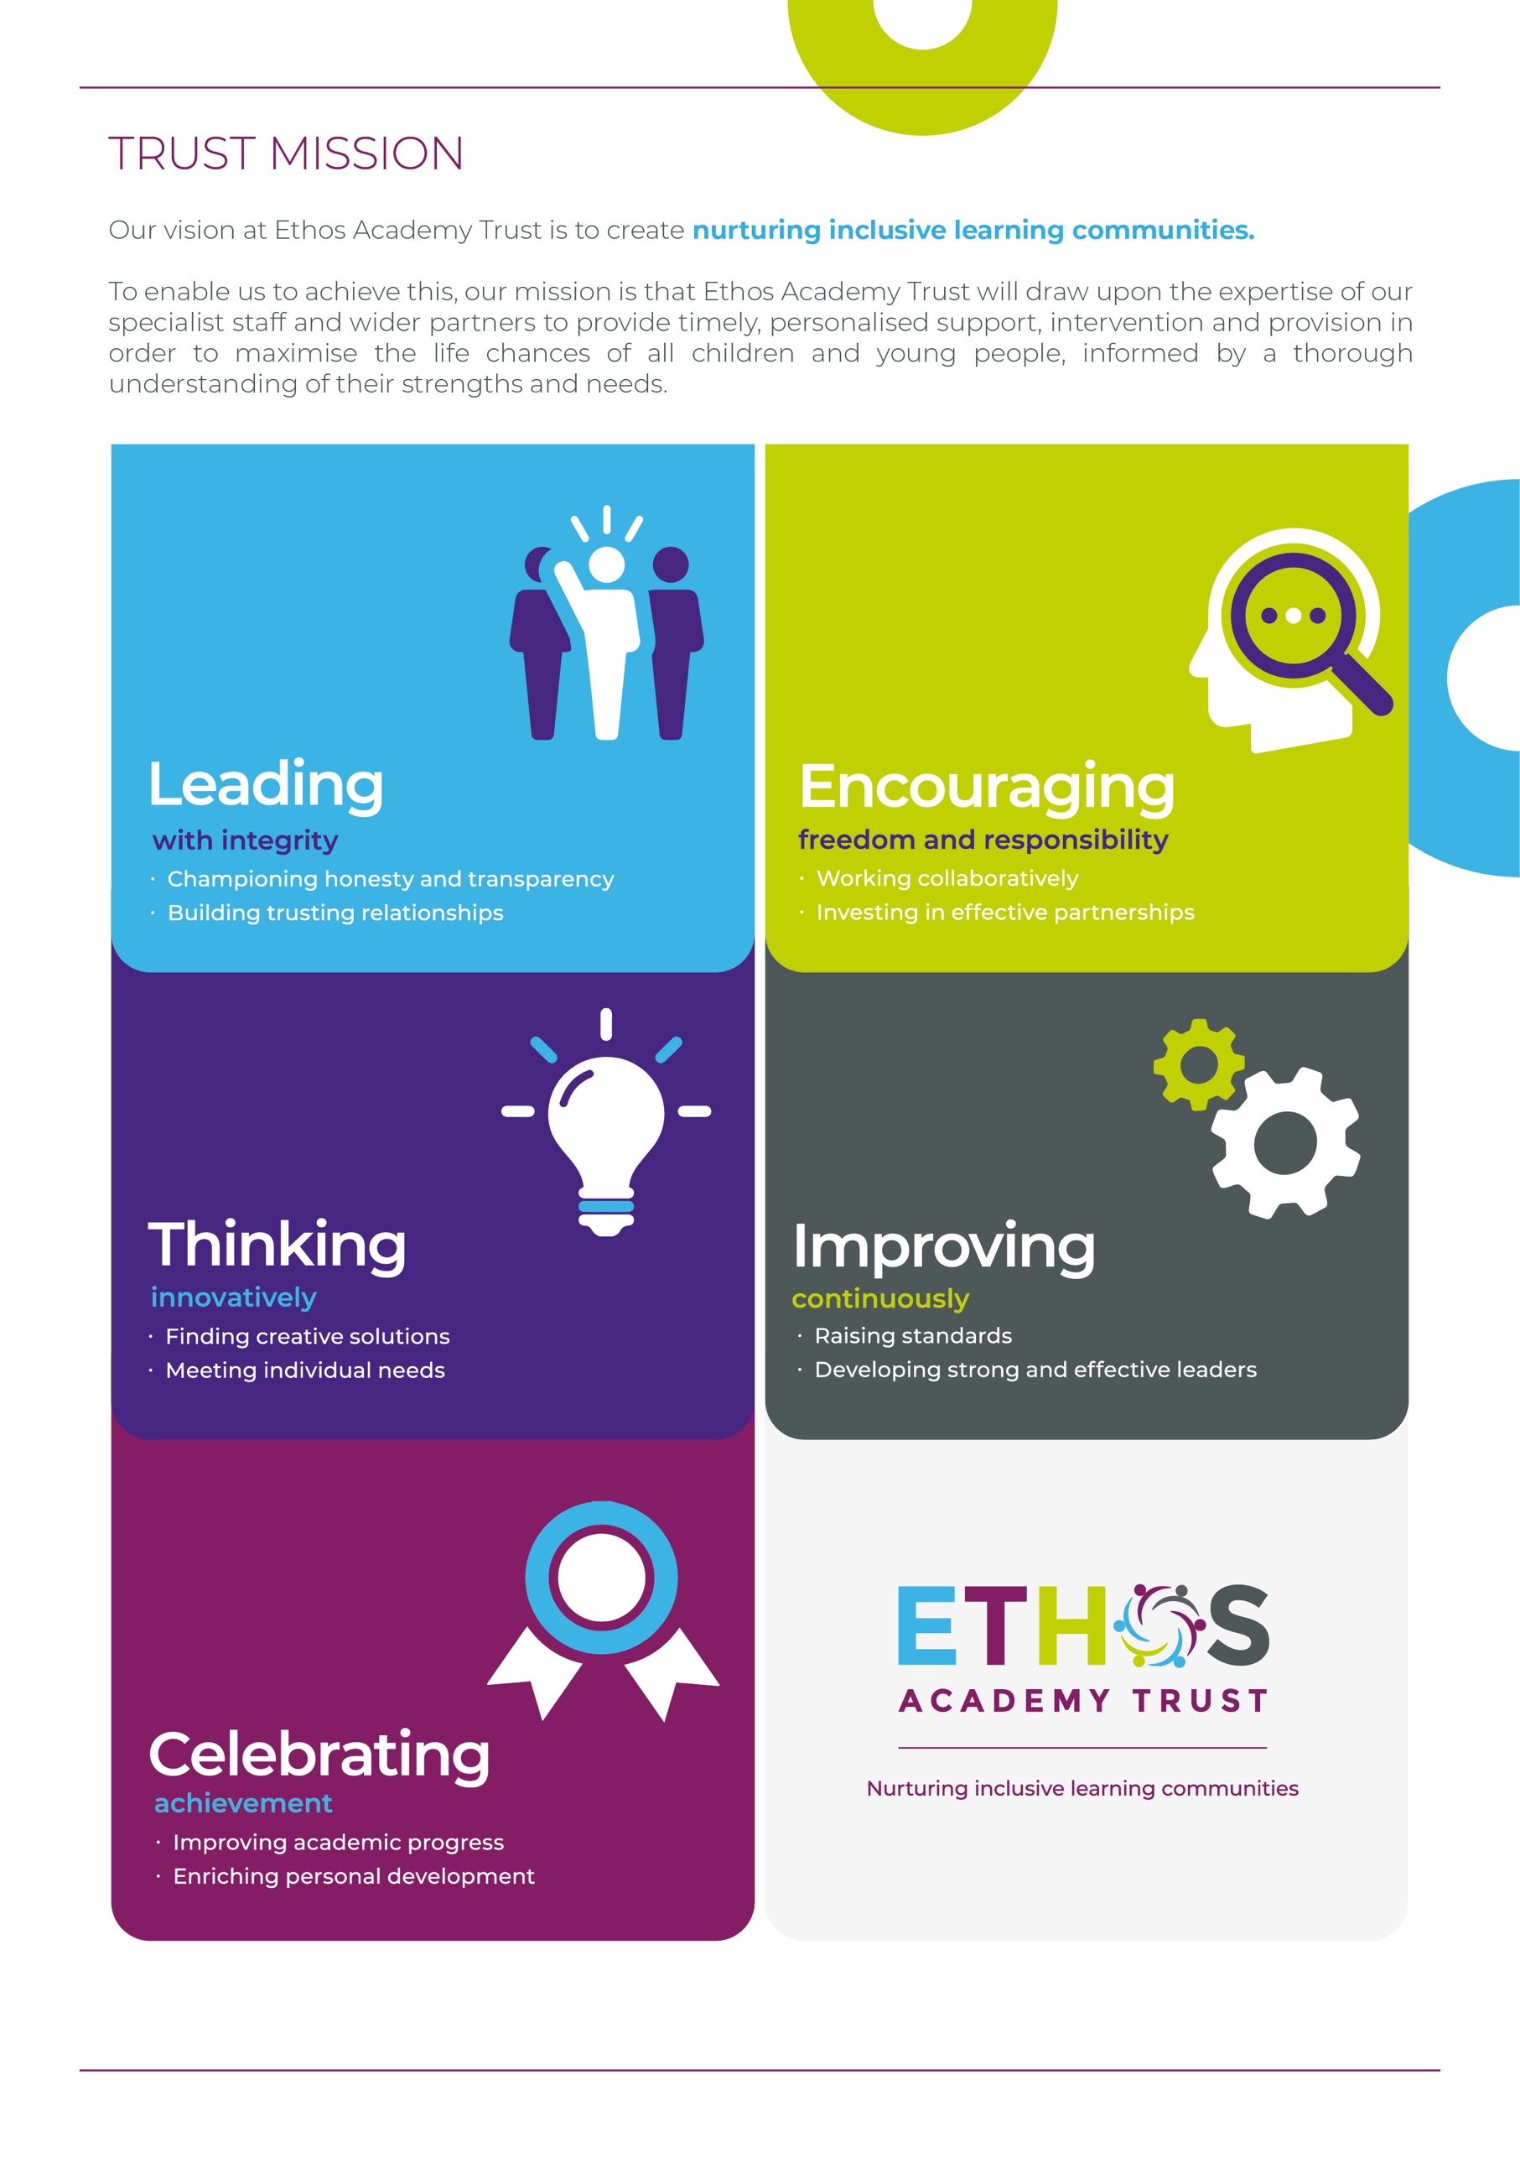

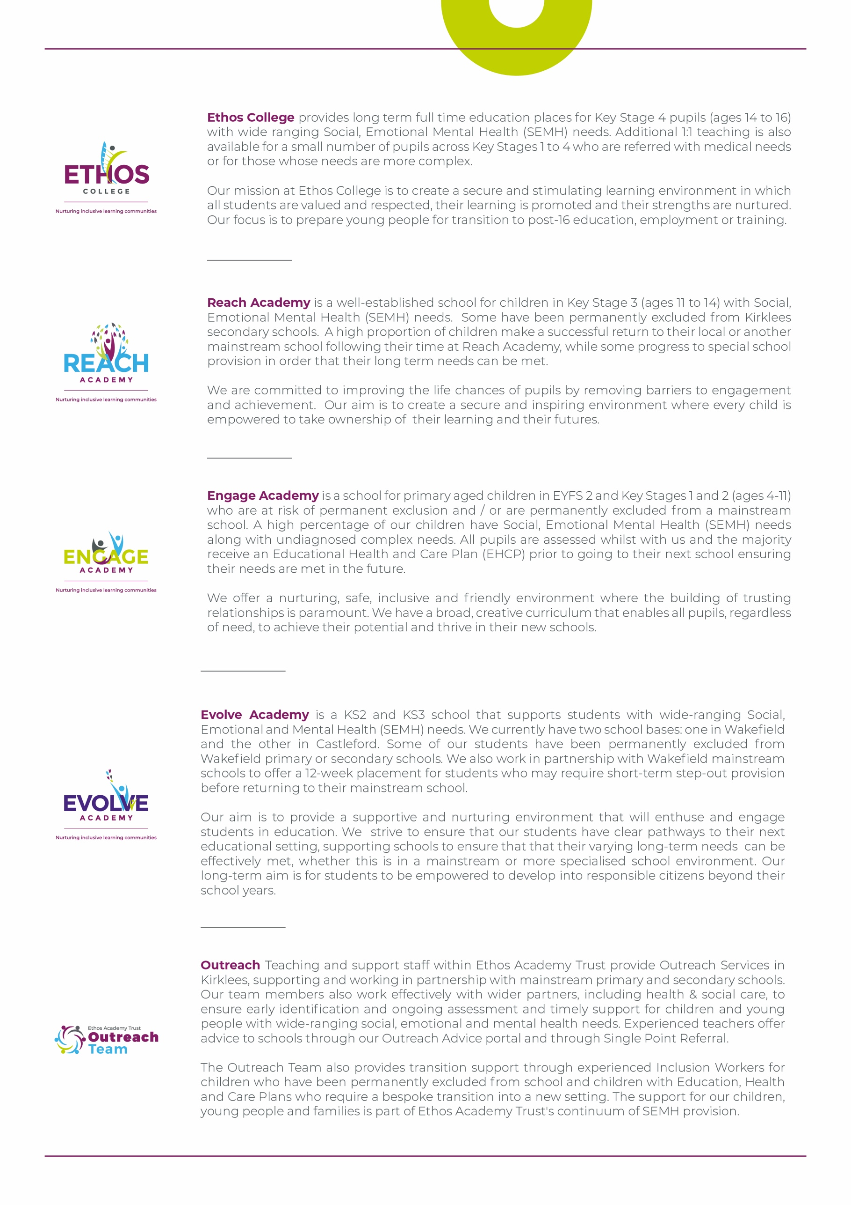

WHY WORK FOR THE TRUST?

Ethos Academy Trust is based in West Yorkshire, with all of our Academies in close proximity to one another and in easy reach of main motorways and the cities and towns of Leeds, Wakefield, Huddersfield and Bradford. The proximity of our Academies is such that it lends itself to close and collaborative working.

At Ethos Academy Trust, we are committed to providing a top-class education and we put the needs of all of the young people within our community at the heart of what we do. Our staff are pivotal in this and also in recognising, achieving and bringing to life our vision and values.

As such, we are committed to providing our staff with high quality professional development which can be evidenced through a variety of channels. We have numerous examples of staff who have developed and progressed their careers with the Trust. We fully embrace the fact that if we invest in our staff and their futures, we will create an environment where staff are happy, inspired and ambitious, which in turn means that they are able to create positive, engaging and life changing learning experiences for young people.

Ethos Academy Trust is fully committed to supporting and enhancing the wellbeing and mental health of all stakeholders. Across the Trust there are regular opportunities for staff to come together outside of their normal working day in a social or other activity capacity.

As an employer, we are able to provide the following benefits to all members of staff:

- The Trust maintains nationally agreed terms and conditions in relation to pay and conditions for teaching and support staff, and continues to subscribe to local holiday patterns and allowances within the local authority of each academy.
- All employees have the opportunity to access a pension scheme.
- All employees have access to Healthline which includes 24/7 Employee Assistance Programme and services such as physio and counselling for employees and their dependants
- An opportunity to collaborate with colleagues across academies and within the central Trust teams, with other academies and Multi Academy Trusts on a local or regional basis.
- Structured and informal opportunities to develop skills and opportunity to progress, share best practice (locally and nationally).
- Access to employee salary sacrifice schemes such as Cyclescheme, Techscheme and discounted gift cards.

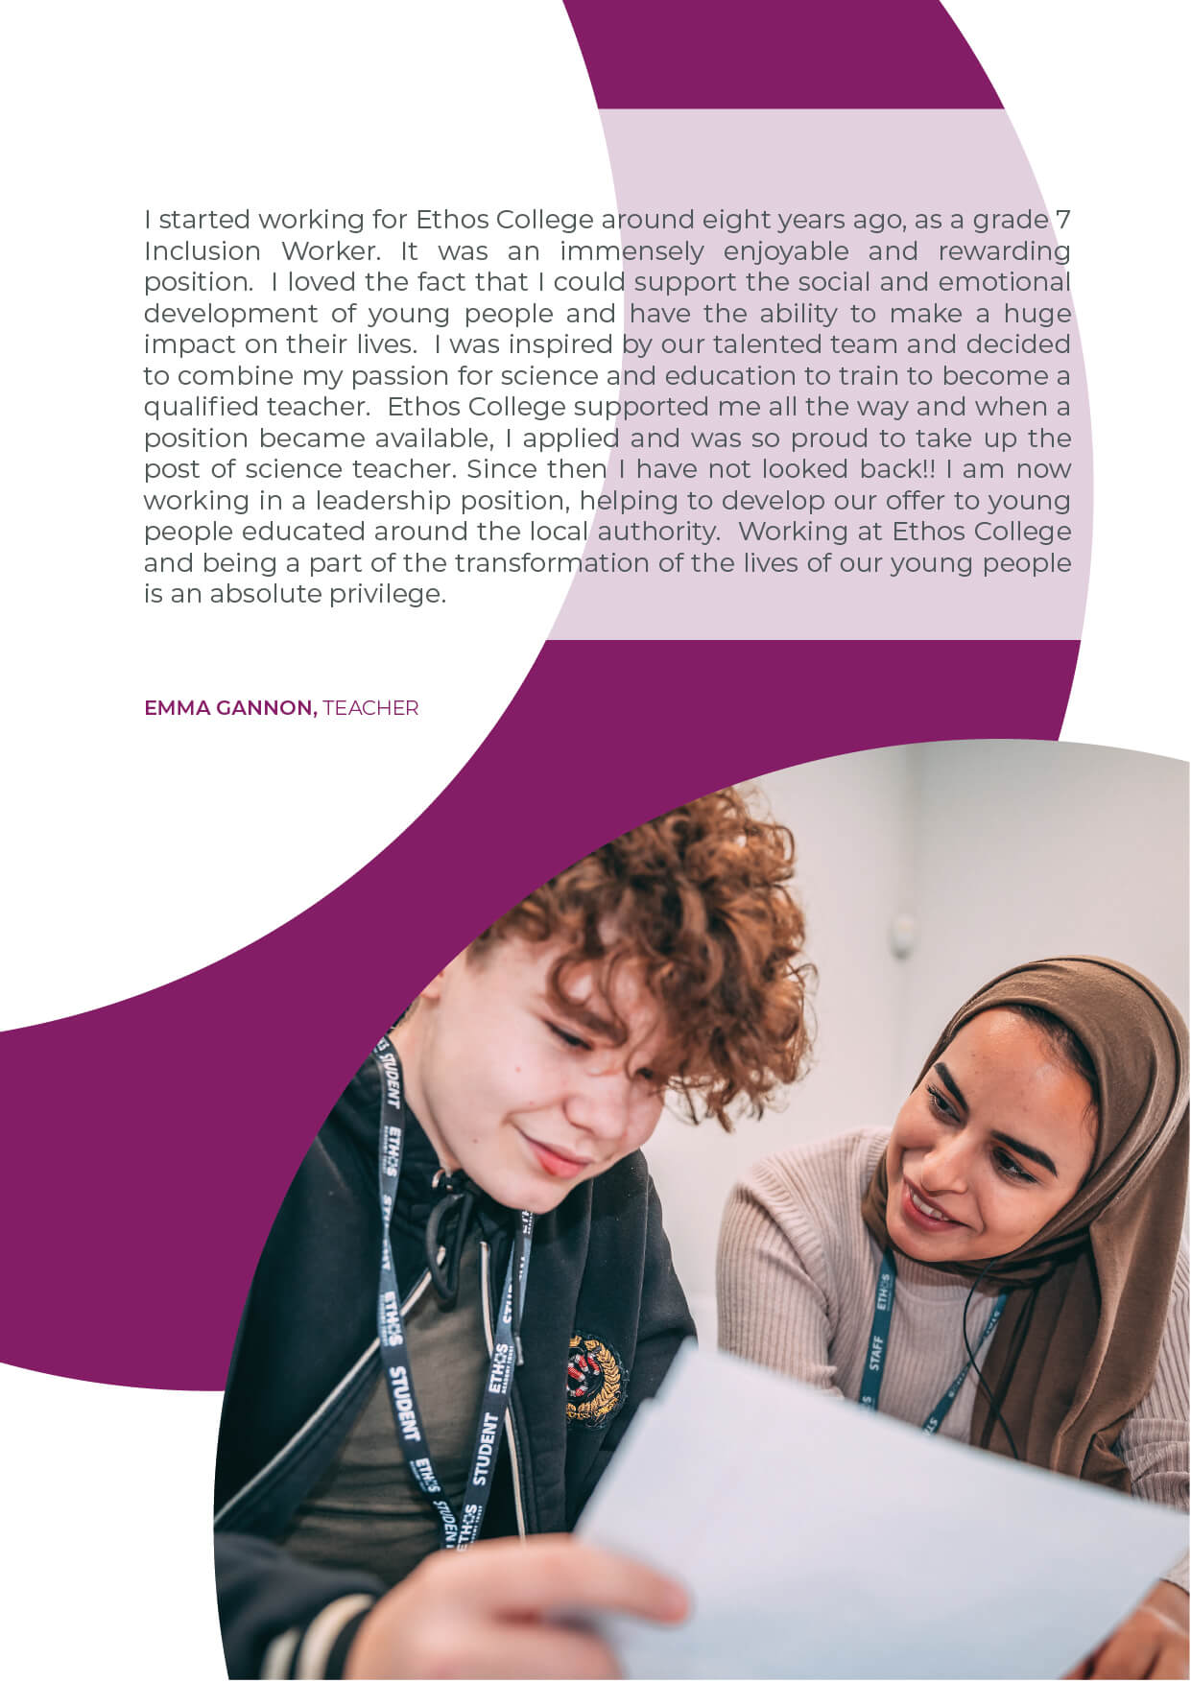
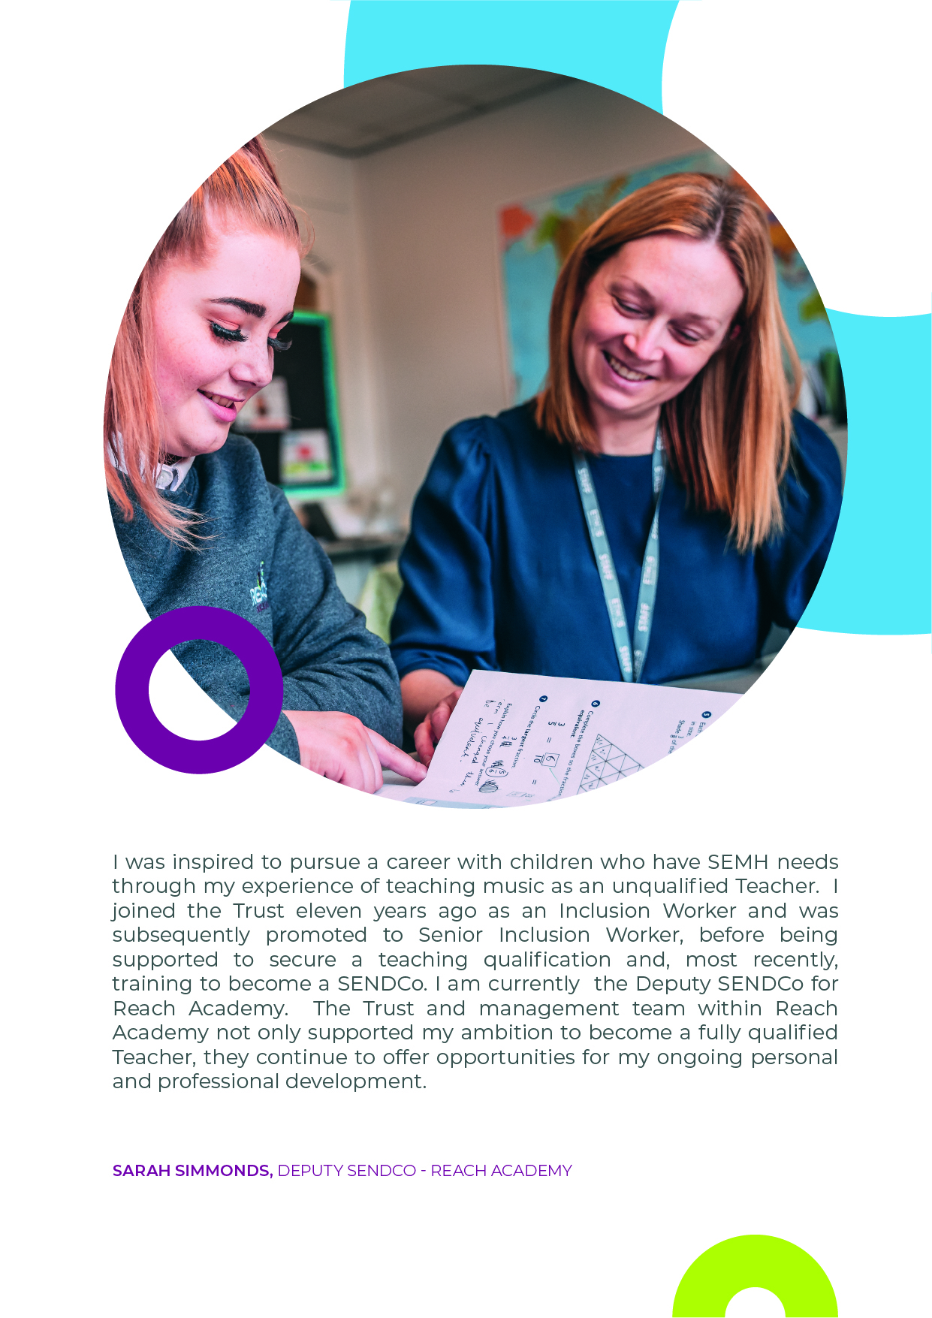

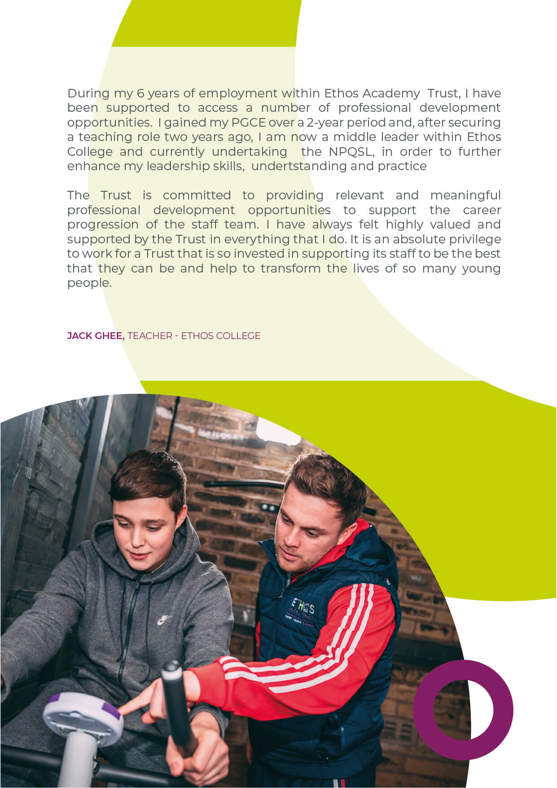
ADVERT FOR INCLUSION WORKER

Inclusion Worker, Reach Academy, Batley
Salary: £23,484 - £24,920 (FTE) (reduced to £17,890 - £18,984 in accordance with the part-time, term time contract plus 5 days)
Grade: 7
Hours: 32.5 hours per week, permanent

About Ethos Academy Trust
Ethos Academy Trust is located within Kirklees and Wakefield, West Yorkshire. The overarching aim of the Trust is to create academies that provide environments that are welcoming, caring, calm, safe and purposeful and that, within a nurturing ethos, stretch our learners academically, support them pastorally and develop them socially and emotionally.

We seek to explore and celebrate the qualities that make our pupils unique. We believe passionately that education, at every stage of the pupil journey, is about the development and nurture of the whole child. We aspire for all our pupils to become confident, happy and caring individuals who achieve personal success and develop a love of learning and of life.

In addition to our four academies (Ethos College, Reach Academy, Engage Academy and Evolve Academy), the Trust provides wide ranging early intervention outreach support and training to mainstream schools, alongside managing the statutory exclusions process on behalf of Kirklees and Wakefield Local Authorities.

Applicants
This is an exciting opportunity to join Ethos Academy Trust, where we aim to deliver the very best educational experiences for pupils from across the primary and secondary age range. Our academies are welcoming, calm and purposeful and, within a nurturing ethos, our learners are stretched academically, supported pastorally and developed socially and emotionally.

We are looking to appoint an inspirational Inclusion Worker (Classroom Assistant) to join our passionate and hardworking team at Reach Academy. Reach Academy is rated as “Good” by Ofsted and is an Alternative Provision for Key Stage 3 pupils.

The role will be to successfully motivate, inspire and engage vulnerable children and their families. You will assist in the delivery of lessons to pupils in a group and also support pupils on a 1:1 basis (in and out of the classroom environment), to re-focus pupils in learning and engagement. You will be key in the development of pupils’ essential skills and emotional resilience in a stimulating and supportive environment. You will be required to work imaginatively and in partnership with parents and carers, teaching and support staff in schools and other professionals in order to achieve the very best outcomes for the pupils. You will be integral to the success of the pupils at Reach and support their academic and pastoral needs.

Closing date: Monday 21st November 2022
Interview date: 30th November 2022

If you require further information please contact Hava Farooq reachoffice@eat.uk.com

INCLUSION WORKER (CLASSROOM ASSISTANT)
JOB DESCRIPTION

Job title | Inclusion Worker
Location | Batley, West Yorkshire
Hours | 32.5 Hours term time plus 5 Inset days permanent
Reports to | Senior Inclusion Worker/Class Teacher
Staff responsible for | No staff responsibility
Closing Date | Monday 21st November 2022
Salary/Grade | £23,484 - £24,920 FTE (reduced to £17,890 - £18,984 in line with TTO working plus 5 days)
Job Purpose | The Inclusion Worker role will focus on providing positive, aspirational outcomes for pupils with complex social, emotional and mental health (SEMH) needs through high quality support and engagement supporting transition and securing pupils' physical, emotional wellbeing, whilst raising their self-esteem and encouraging independence.  From time to time you may be required to work in different locations which could be in one of our academies or within a school located within the local authority as part of our Outreach Service.

KEY OBJECTIVES AND ACCOUNTABILITIES

Main Duties
- Provide academic support within the classroom, under the direction of the class teacher/line manager to support all pupils to make progress across all curriculum areas.
- Support on the delivery of learning based interventions to support pupils specific learning and social, emotional and mental health needs.
- Support pupil integration into the Academy to ensure pupils receive a positive, high quality transition into the Academy liaising with parents and external agencies.
- Complete pupil assessments and develop plans alongside colleagues to ensure nurture principles and necessary interventions are consistently practiced within classrooms and the wider Academy.
- Work alongside and attend meetings with external agencies and professionals completing relevant associated paperwork to support positive outcomes for pupils and families.
- Use effective strategies to support and promote positive pupil behaviour in line with establish policy including restorative practice, emotion coaching, de-escalation and positive handling (Team Teach).
- Contribute to the development and growth of the Academy working with colleagues to achieve this.
- Update pupils’ records on the relevant systems to record accurate objective reflections as needed.
- Participate in and assist in supervision of educational visits in conjunction with the Teacher or other class leader.
- Undertake relevant training and CPD including attending weekly staff meetings, and be involved in ongoing development reviews of skills and competencies to improve practices
- Supervise and support pupils at break times, lunchtimes and extra-curricular activities and travel to and from the Academy, as required
- Develop trusting relationships with parents/carers through regular contact, keeping parents informed of their child’s progress and support identified needs
- Other duties and responsibilities as may be required by the post holder’s supervisor from time to time, in consultation with the post holder
- Contribute to plans, reviews and evaluations of pupils to support their reintegration to their next educational setting.
General
- Be aware of and support difference and ensure equal opportunities for all.
- Contribute to the overall ethos/work/aims of the Trust.
- Attend meetings within the Trust, at its academies and external events as required.
- Share expertise and skills with others.
- Participate in training and other learning activities and performance development as required.
- Work effectively and professionally with all stakeholders, promoting the Trust positively at all times.
- Recognise own strengths and areas of expertise and use these to advise and support colleagues.
- Maintain confidentiality always in respect of school-related matters and to prevent disclosure of confidential and sensitive information.
- Ensure strict confidentiality in all areas of work.
- All employees are required to uphold the values of democracy, rule of law, individual liberty and tolerance and have mutual respect for those with different faiths and beliefs (Prevent).
- Work and process personal and sensitive information in accordance with Data Protection Act 2018 including the General Data Protection Regulations (GDPR) 2018.
- Understand and comply with the statutory guidance regarding safeguarding of children, ensuring the safeguarding and promotion of children’s welfare at all times, reporting any concerns to the Designated Safeguarding Lead immediately.
Other duties - Outreach
- Supporting transition and early Intervention In mainstream settings
- Observe and monitor pupil progress, adapting an agreed approach to meet particular needs.
- Recording and maintaining records of pupils’ development and progress.
- Implement and evaluate specialised programmes of work to encourage and promote a pupil’s social emotional and behavioural development.

PERSON SPECIFICATION

 | Key Criteria | Essential (E) / Desirable (D)
Knowledge, Education and Training | GCSE grade 4 or above (grade C or above) in English and Maths or the ability to demonstrate equivalent knowledge | E
 | Professional qualifications applicable to the role (e.g. teaching assistant qualification) | D
 | Understanding and knowledge of strategies to support social, emotional and mental health development | D
Relevant Experience | Experience working with children or young people | E
 | Experience of working in an educational setting | D
 | Experience of supporting pupils academic and pastoral development in a school environment | D
 | Experience of supporting pupils’ basic skills in English and Maths | D
 | Experience of supporting pupils’ through interventions | D
 | Experience of working collaboratively with and attending meetings with external agencies and professionals to ensure positive outcomes for pupils and families | D
 | Experience of working closely with families to improve outcomes for pupils | D
 | Experience of working with pupils with barriers to their learning as a result of a social, emotional or mental health need | D
Aptitudes, skills and competencies | Ability to assist the class teacher in planning class activities | E
 | Ability to communicate effectively with pupils, staff, other schools and other professional | E
 | Ability to relate to pupils from diverse social backgrounds | E
 | Ability to work as a team member | E
 | Ability to work with pupils exhibiting challenging behaviour | E
 | Ability to engage and work effectively with hard to reach parents and key family members | E
 | Willingness to lead on extra-curricular activities | E
 | Ability and willingness to drive the school minibus and obtain business insurance on own car insurance | E
 | Understanding and experience of primary learning programmes and interventions | E
 | Understanding of child development, learning and nurture principles | E
 | Knowledge of the national curriculum applicable to the Academy | E
 | Understanding of safeguarding procedures and issues | E
Any additional factors | Motivated to work with pupils with a wide range of learning, social, emotional and health needs | E
 | Emotional resilience in working with pupils with exhibit challenging behaviour | E
 | The post holder may be required to work outside of normal school hours on occasion with due notice | E
 | Willingness to be flexible and adaptable, leading a team by modelling a positive, professional approach, in a variety of situations. | E
 | Willingness to undergo an enhanced DBS check and sign up to the DBS service on an annual basis | E
 | Commitment to ongoing personal training and development | E
 | Willingness to work offsite with pupils and families | E
 | Hold a valid full UK driving licence | E
 | Willingness to work across multi academy trust sites in different key stages | E
 | Understanding of relevant policies/codes of practice and awareness of relevant legislation | D

Safeguarding statement
Ethos Academy Trust is committed to safeguarding and promoting the welfare of children and applicants must be willing to undergo child protection screening appropriate to the post, including an Enhanced DBS check (including Children’s Barred List) and past employment references.

Applicants are required, before appointment to disclose any conviction, caution or binding over including ‘spent convictions’ under the Rehabilitation of Offenders Act 1974 (Exemptions) Order 1975.

Equality and Diversity statement
Ethos Academy Trust treats all applicants for employment in the same way regardless of age, disability, gender reassignment, marriage and civil partnership, pregnancy and maternity, race, religion or belief, sex or sexual orientation.

Disability statement
Ethos Academy Trust is committed to promoting equality of opportunity for people with disabilities. We continue to review our processes and procedures to ensure individuals with disabilities receive full and fair consideration for all types of vacancies at the recruitment stage and during their employment.

Individuals who apply to the Trust for employment will receive fair treatment and be considered solely on their ability to do the job. Where required reasonable adjustments will be applied. During employment the Trust, wherever possible, will retain the services of an employee who is or has become disabled.

GDPR
A copy of our Privacy Notice is available via our website.
www.eat.co.uk

