
CEO WELCOME
Deputy Head Teacher,
Quality of Education

Dear Applicant,

Thank you for your interest in this vital post of Deputy Head Teacher, Quality of Education at Ethos Academy Trust. We hope that the information contained within this pack provides sufficient information and helps you to decide if you have the right qualities, skills and experience to apply for this position.

The overarching aim of Ethos Academy Trust is to create academies that provide environments that are welcoming, caring, calm, safe and purposeful and that, within a nurturing ethos, stretch our learners academically, support them pastorally and develop them socially and emotionally.

We seek to explore and celebrate the qualities that make our pupils unique. We believe passionately that education, at every stage of the pupil journey, is about the development and nurture of the whole child. We aspire for all our pupils to become confident, happy and caring individuals who achieve personal success and develop a love of learning and of life.

We currently have five academies (Ethos College, Reach Academy, Evolve Academy, Engage Academy and Elements Academy) and we have high aspirations for future growth. In addition to the academies, the Trust provides wide ranging early intervention outreach support and training to mainstream schools, alongside managing the statutory exclusions process on behalf of Kirklees Local Authority.

Thank you for your interest in Ethos Academy Trust.

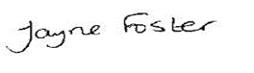
Jayne Foster
CEO, Ethos Academy Trust

HEADTEACHER WELCOME

Dear Applicant

Elements Academy is a new special school which opened in September 2022 in Rotherham, South Yorkshire. It will offer 135 places for Key Stage 2 – 4 pupils (aged 7-16) who have an Education, Health and Care Plan (EHCP) where Social, Emotional and Mental Health (SEMH) is identified as the primary need.

Ethos Academy Trust has a long-standing reputation for achieving outstanding outcomes with vulnerable pupils. Our nurture-based philosophy underpins our practice. At Elements Academy, we will provide a caring, stimulating, safe and welcoming environment where learning is enjoyable, and teaching is personalised to the needs and interests of individuals. Pupils will be supported to fulfil their academic potential whilst developing the long-term confidence and skills required to succeed in post-16 education, employment or training.

Our outstanding staff teams are skilled at working with young people with needs across the SEMH range. In partnership with parents, carers and other professionals, we will take a holistic approach to ensuring a young person’s needs are identified and met throughout their journey at Elements Academy, preparing them for the next stage of their lives.

At Elements Academy, you will find strong, hardworking and dedicated members of staff. We believe in investing in our staff team and all staff have the opportunity to access high quality internal and external professional development. Working within Ethos Academy Trust is extremely rewarding; making a difference to vulnerable children and young people, knowing that the work you do has a genuine, long-term impact on a young person’s education and life chances.

We are seeking to appoint a Deputy Head Teacher, Quality of Education to join our team. The successful applicant must be dedicated to supporting our young people to reach their full potential. We would like to thank you for your interest in Elements Academy and we look forward to receiving your application.

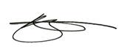

Vicky Woodrow
Head Teacher

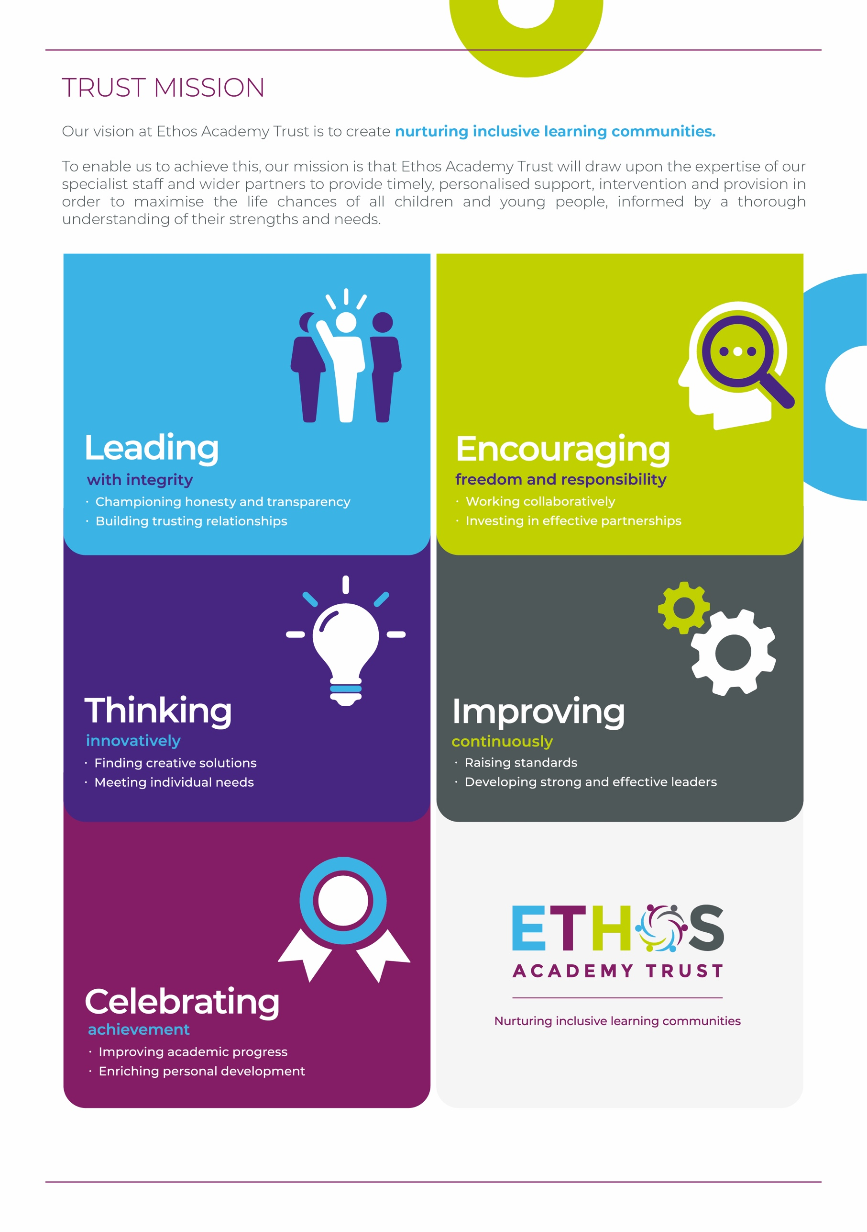

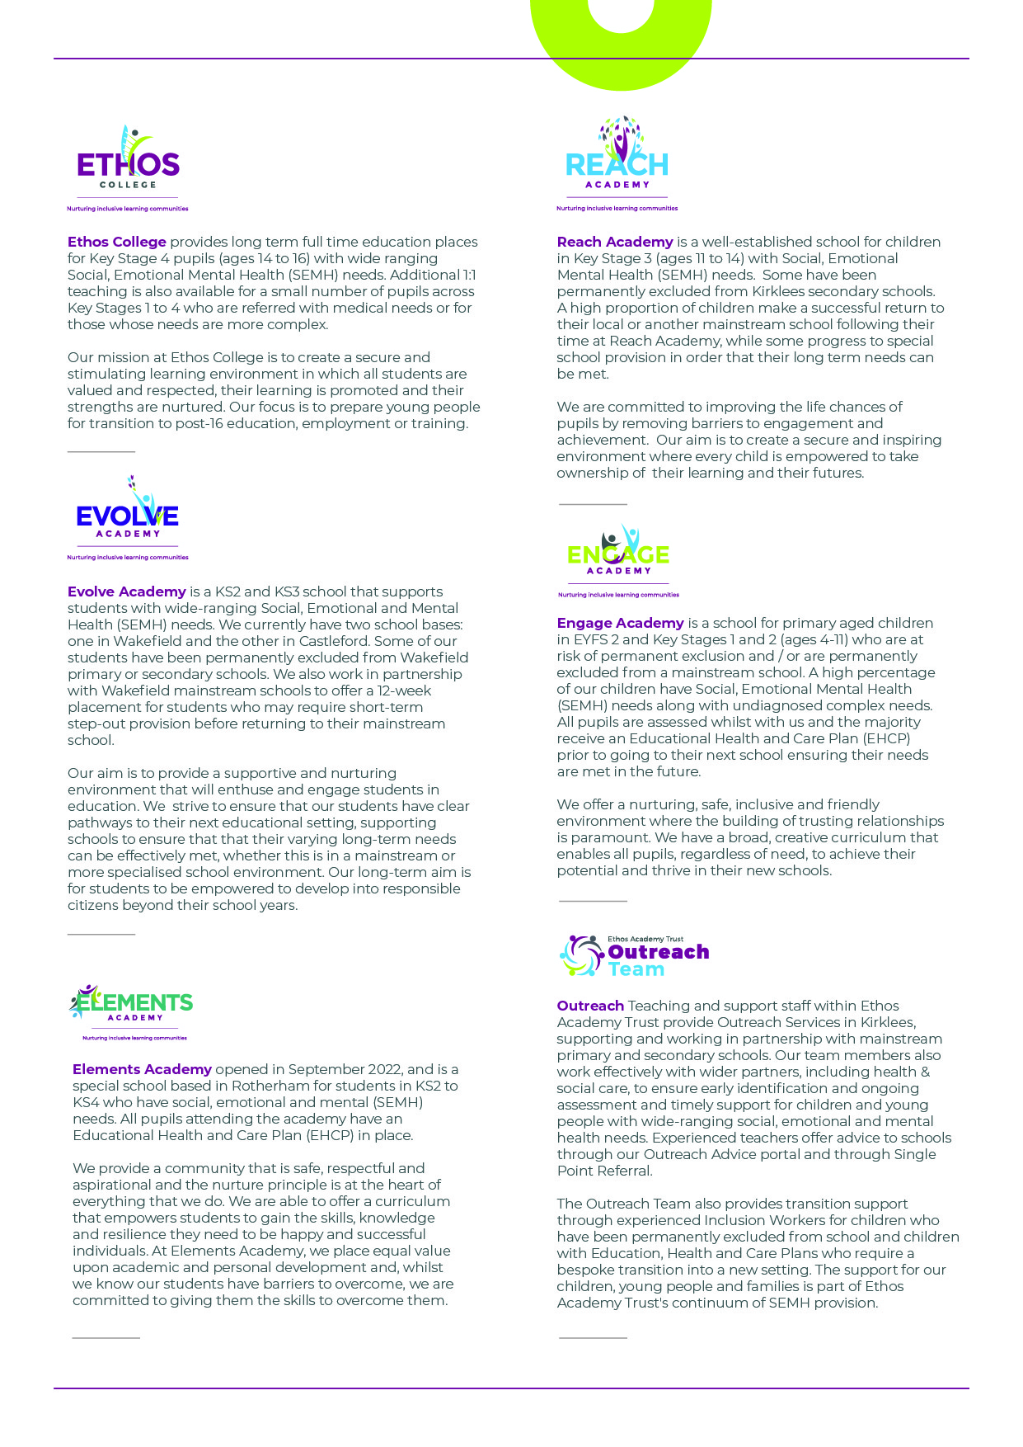

WHY WORK FOR THE TRUST?

Ethos Academy Trust is based in West Yorkshire, with all of our Academies in close proximity to one another and in easy reach of main motorways and the cities and towns of Leeds, Wakefield, Huddersfield, Bradford and Rotherham. The proximity of our Academies is such that it lends itself to close and collaborative working.

At Ethos Academy Trust, we are committed to providing a top-class education and we put the needs of all of the young people within our community at the heart of what we do. Our staff are pivotal in this and also in recognising, achieving and bringing to life our vision and values.

As such, we are committed to providing our staff with high quality professional development which can be evidenced through a variety of channels. We have numerous examples of staff who have developed and progressed their careers with the Trust. We fully embrace the fact that if we invest in our staff and their futures, we will create an environment where staff are happy, inspired and ambitious, which in turn means that they are able to create positive, engaging and life changing learning experiences for young people.

Ethos Academy Trust is fully committed to supporting and enhancing the wellbeing and mental health of all stakeholders. Across the Trust there are regular opportunities for staff to come together outside of their normal working day in a social or other activity capacity.

As an employer, we are able to provide the following benefits to all members of staff:

- The Trust maintains nationally agreed terms and conditions in relation to pay and conditions for teaching and support staff, and continues to subscribe to local holiday patterns and allowances within the local authority of each academy.
- All employees have the opportunity to access a pension scheme.
- All employees have access to Healthline which includes 24/7 Employee Assistance Programme and services such as physio and counselling for employees and their dependants
- An opportunity to collaborate with colleagues across academies and within the central Trust teams, with other academies and Multi Academy Trusts on a local or regional basis.
- Structured and informal opportunities to develop skills and opportunity to progress, share best practice (locally and nationally).
- Access to employee salary sacrifice schemes such as Cyclescheme, Techscheme and discounted gift cards.


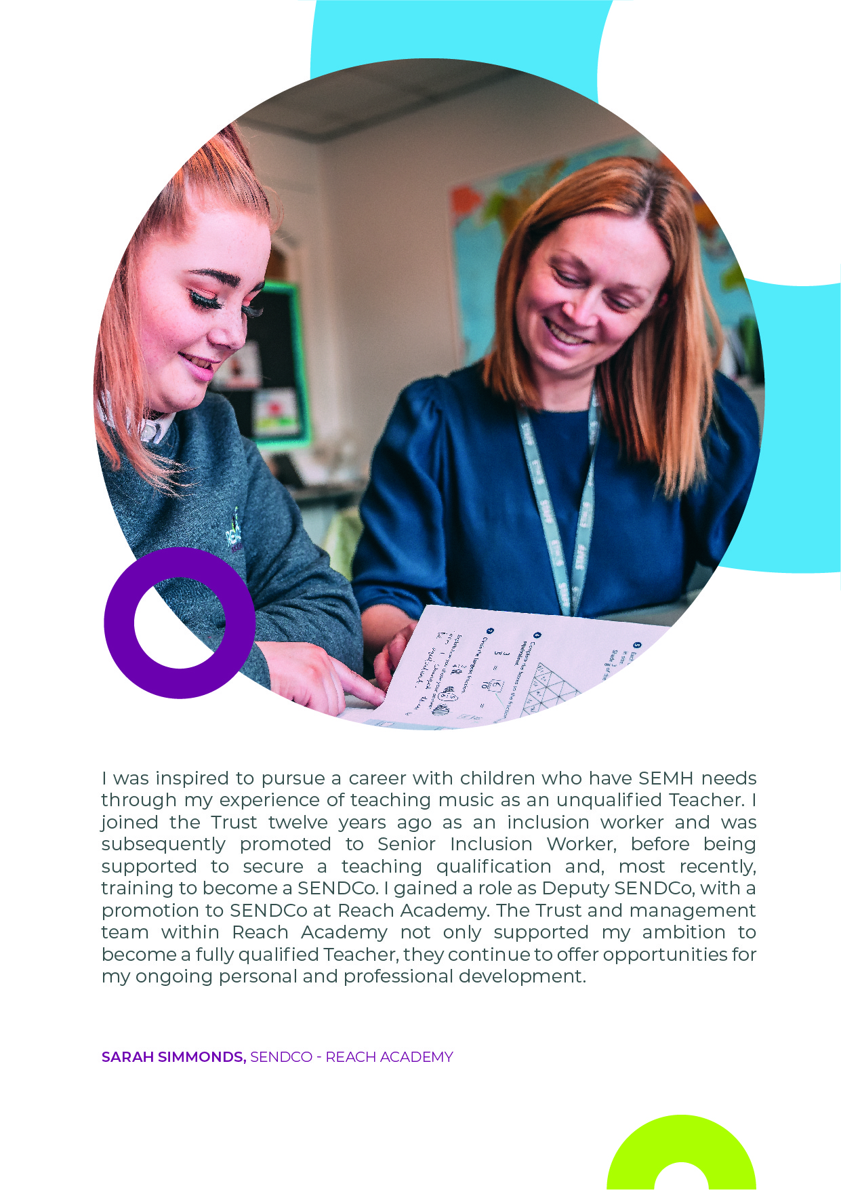

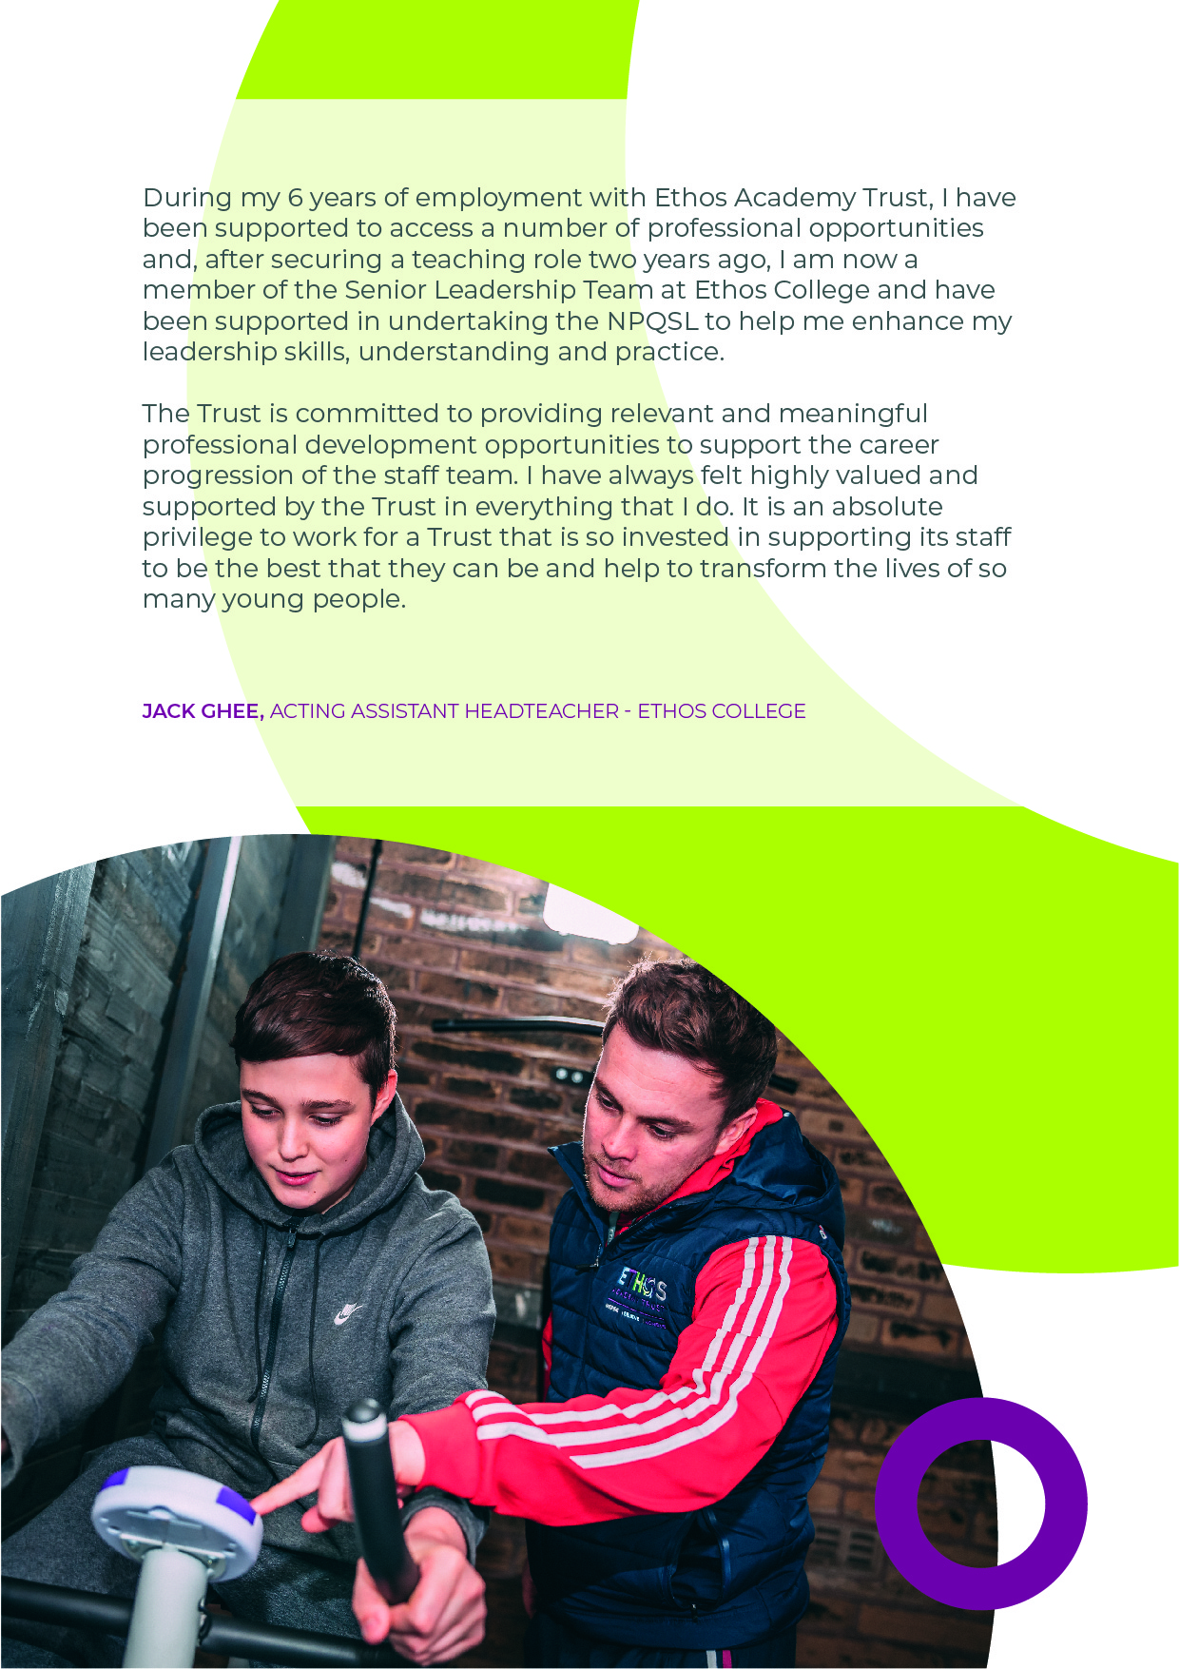

DEPUTY HEAD TEACHER,
QUALITY OF EDUCATION

Grade: L12 – L16 (£58,105 - £64,225)
Full time, permanent
Closing date: Monday 20th February 2023 at 9.00am

About Ethos Academy Trust
Ethos Academy Trust is located within Kirklees and Wakefield, West Yorkshire and Rotherham, South Yorkshire. The overarching aim of the Trust is to create academies that provide environments that are welcoming, caring, calm, safe and purposeful and that, within a nurturing ethos, stretch our learners academically, support them pastorally and develop them socially and emotionally.

We seek to explore and celebrate the qualities that make our pupils unique. We believe passionately that education, at every stage of the pupil journey, is about the development and nurture of the whole child. We aspire for all our pupils to become confident, happy and caring individuals who achieve personal success and develop a love of learning and of life.

In addition to our five academies (Ethos College, Reach Academy, Engage Academy, Evolve Academy and Elements Academy), the Trust provides wide ranging early intervention outreach support and training to mainstream schools, alongside managing the statutory exclusions process on behalf of Kirklees and Wakefield Local Authorities.

Applicants
This is an exciting opportunity to join Ethos Academy Trust, where we aim to deliver the very best educational experiences for pupils from across the primary and secondary age range. Our academies are welcoming, calm and purposeful and, within a nurturing ethos, our learners are stretched academically, supported pastorally and developed socially and emotionally.

We are looking to appoint a Deputy Head Teacher, Quality of Education to join our passionate and hardworking team at Elements Academy. You will assist the Head Teacher in the strategic leadership and management of the academy, and in all aspects of school improvement. You will provide leadership and direction for significant aspects of the academy, ensuring it is effectively managed and organised, by working strategically with all partners and stakeholders to develop outstanding provision, which will transform the educational and future life opportunities of all pupils. It is essential that you hold QTS and an NPQSL qualification (or willingness to work towards). You will possess substantial experience in a leadership role, with broad experience of strategic leadership, impacting positively and leading to improved standards at whole school level. In addition, you will have experience of leading, developing, delivering and evaluating effective strategies for learners with SEN, in particular children with SEMH needs.

If you are looking for a new and rewarding challenge in education, you are committed and passionate then we look forward to hearing from you.

Closing date: Monday 20th February 2023 at 9.00am
Interview date: Thursday 23rd and Friday 24th February 2023

If you require further information or would like to arrange a visit, please contact Kathryn.bower@eat.uk.com

You can apply for the vacancy at https://www.eat.uk.com/recruitment-portal/current-opportunities/

DEPUTY HEAD TEACHER, QUALITY OF EDUCATION
JOB DESCRIPTION

Job title | Deputy Head Teacher, Quality of Education
Location | Elements Academy
Hours | Full-time, permanent
Reports to | Head Teacher
Staff responsible for | Determined by Line Management structure
Closing Date | 20th February 2023 at 9.00am
Salary/  Grade | L12 - L16
Job Purpose | To assist the Head Teacher in the strategic leadership and management of Elements Academy and its off-site provision, Elevate, and in all aspects of school improvement. As Deputy Head Teacher, the postholder will provide leadership and direction for significant aspects of the academy, ensuring it is effectively managed and organised, by working strategically with all partners and stakeholders to develop outstanding provision, which will transform the educational and future life opportunities of all pupils.

KEY OBJECTIVES AND ACCOUNTABILITIES

Main Duties

Leadership and Management

- Strategically lead, develop and implement quality assurance processes to monitor and evaluate standards across the whole school and actively model and promote effective teaching and learning.
- Strategically lead in shaping a vision for the curriculum and the curriculum design for all pupils, exemplifying high expectations and with a clear focus on teaching, learning and progress.
- Play a significant role in setting aims and objectives and in formulating, implementing and reviewing the impact of School Development Plans.
- Inspire, motivate and influence staff and pupils, taking a leading role in maintaining the highest standards of pupil discipline, offering guidance and support to colleagues.
- Take a significant role in the implementation of the Trust’s Performance Management and Appraisal policies, to secure school improvement and individual professional development.
- Identify and address aspects of training needs for the staff team ensuring that continued professional development has a direct impact on the development of provision outcomes for pupils.
- To make a significant contribution to the academy’s continuing professional development programme, including co-ordinating training programmes, delivering INSET and working with individuals and teams in a variety of professional development activities.
- Contribute and lead elements of academy self-evaluation and developing planning processes.
- Assist the Head Teacher, having a direct impact in raising achievements to the highest-level for all children through uncompromising high ambition.
- Develop, implement and quality assure effective systems of communication, including reports to key stakeholders.
- Take full responsibility for leading and managing a significant aspect of the strategic leadership and performance of the academy under the overall direction of the Head Teacher.
- Teach and undertake the professional responsibilities of the Deputy Head Teacher in accordance with Teachers Pay and Conditions document and as directed by the Head Teacher.
- To assist the Head Teacher in the day to day running of the academy and deputise in their absence.
- To maintain an informed view of standards and the quality of teaching across the academy by monitoring pupils’ work and teachers’ planning and teaching.
- To actively promote equality of opportunity by assisting the Head Teacher in ensuring the academy’s curriculum provides the best possible education for all its pupils.
- Be a lead professional and positive role model within our community, helping others recognise difference and respect diversity.
- To play a significant role in setting aims and objectives and in formulating the Academy Improvement Plan, taking responsibility for monitoring implementation and impact.
- Have a direct impact in raising achievements to the highest level for all children through uncompromising high ambition of staff and pupils.

Quality of Education

- To ensure that the whole school and subject curriculum have clear curriculum intent and align to the academy’s vision and values.
- To ensure that the academy’s curriculum offer provides continuity of learning and the building of powerful knowledge, skills and competencies for learning.
- To build curriculum offers that demonstrate aspiration, high expectations for our pupils and fully prepare them for the next phase of their learning, enabling them to progress successfully.
- To maintain a deep understanding and knowledge of the local, national and political educational picture.
- To be responsible for developing quality assurance processes to audit, monitor and evaluate the quality and impact of the curriculum offered by each subject in the academy.
- To develop and maintain strong partnerships with educational institutions, training organisations and employers to enrich and enhance the curriculum.
- To ensure the academy has an unswerving focus on improving the quality of teaching and learning and set challenging targets for improvement with clear milestones and regularly report on the progress towards these.
- To ensure that where monitoring and evaluation identifies serious concerns, urgent action is taken to address these by following Trust processes.
- To ensure that evidence from monitoring and evaluation informs the CPD programme in terms of sharing best practice and identifying areas for development.
- To be responsible for leading and coordinating the academy’s CPD that contributes to the raising of standards.
- To produce termly reports on the quality of education to the Headteacher and CEO.
- To sustain effective systems in the line management and appraisals of direct reports.
- To lead the academy’s development of policies relating to the Quality of Education.
- To ensure that there are effective processes for assessment and marking – providing pupils with accurate and reliable feedback that helps them progress and informs teachers about future planning.
- To be responsible for ensuring that robust and consistent systems are in place for tracking and monitoring the progress of pupils at whole school, subject, cohorts and individual levels.
- To ensure that the academy has very clear, rigorous and robust processes in place for monitoring and tracking the progress of every pupil in order to identify underachieving students and provide intervention where necessary.
- To ensure that the academy has robust processes for moderating and standardising assessment data to ensure accurate and reliable data.
- Chair meetings and lead / be a member of key strategic working parties within and beyond the Trust.
General
- Be aware of and support difference and ensure equal opportunities for all;
- Attend meetings within the Trust and external events as required;
- Share expertise and skills with others;
- Recognise own strengths and areas of expertise and use these to advise and support colleagues;
- All employees are required to uphold the values of democracy, rule of law, individual liberty and tolerance and have mutual respect for those with different faiths and beliefs (Prevent).
- Work and process personal and sensitive information in accordance with Data Protection Act 2018 including the General Data Protection Regulations (GDPR) 2018.
- Understand and comply with the statutory guidance regarding safeguarding of children, ensuring the safeguarding and promotion of children’s welfare at all times, reporting any concerns to the Designated Safeguarding Lead immediately.
- To act with integrity, honesty and professional competence and understand the importance of confidentiality.
- To have a positive attitude towards working with vulnerable young people including ability to be understanding, responsive, calm and supportive.
- Carry out your duties with due regard to current and future Academy policies, procedures and relevant legislation. These will be drawn to your attention in your appointment letter, induction and on-going performance development and through Academy communications.
- Take reasonable care of the health and safety of self, other persons and resources whilst ay work. This entails supporting the college’s responsibilities under the Health and Safety at Work Act
- Demonstrate day to day commitment to the Trust’s core values of community and mission statement
- Carry out such reasonable additional duties as may from time to time to determined by or on behalf of the Trust Board.

PERSON SPECIFICATION

 | Key Criteria | Essential (E) / Desirable (D)
Knowledge, Education and Training | Hold qualified teacher status. | E
Knowledge, Education and Training | Hold an NPQSL qualification, or a willingness to work towards. | E
Knowledge, Education and Training | Have evidence of recent CPD to fulfil the requirements of the role. | E
Knowledge, Education and Training | Evidence of post graduate study. | D
Knowledge, Education and Training | Knowledge of Ofsted inspection criteria and processes for the Quality of Education. | E
Knowledge, Education and Training | Understanding of effective strategies for gaining and maintaining high standards of discipline at whole-school level . | E
Knowledge, Education and Training | Understanding of current theory and practice of best practice in teaching and learning. | E
Knowledge, Education and Training | An understanding of how the role of parents and the community in school improvement can be promoted and developed. | E
Relevant Experience | Proven and substantial experience of a highly successful teaching career. | E
Relevant Experience | Substantial experience in a leadership role, with broad experience of strategic leadership, impacting positively and leading to improved standards at whole school level. | E
Relevant Experience | Have experience of leading, developing, delivering and evaluating effective strategies for learners with SEN, in particular children with SEMH needs. | E
Relevant Experience | Experience of developing and implementing strategies for school improvement, including data analysis, target setting and strategies for improving the quality of education for all pupils. | E
Relevant Experience | Experience of curriculum design across key stages. | E
Relevant Experience | Experience of leading on staff development initiatives, mentoring staff and taking a lead on systems for managing performance and under performance . | E
Relevant Experience | Experience of setting ambitious standards for all pupils, overcoming disadvantage and advancing equality, ensuring the accountability of staff for the impact of their work. | E
Relevant Experience | Experience of implementing clear policies and practices throughout the academy, including monitoring and evaluating their impact. | E
Relevant Experience | Experience of improving the quality of teaching and learning through processes of monitoring and support. | E
Relevant Experience | Experience of initiating and implementing strategies to improve parental involvement in their child’s learning . | E
Aptitudes, skills and competencies | Ability to provide a model of best practices, through teaching in own or others’ settings . | E
Aptitudes, skills and competencies | The ability to contribute to the day-to-day demands of a Senior Leadership Team. | E
Aptitudes, skills and competencies | Demonstrate leadership qualities, resilience and the ability to enthuse, empower, motivate others and work flexibly as part of a team. | E
Aptitudes, skills and competencies | Articulate a clear vision for high quality education in a special school context . | E
Aptitudes, skills and competencies | Effective communication skills both orally and in writing to a diverse range of audiences internally and externally, maintaining an effective network of contacts . | E
Aptitudes, skills and competencies | To relate well and be responsive to the requirements of pupils with SEMH needs . | E
Aptitudes, skills and competencies | Work effectively under pressure with the ability to prioritise to meet deadlines . | E
Aptitudes, skills and competencies | Good analytical skills, being able to synthesise complex information, summarise, draw appropriate conclusions and make decisions, to present school performance and financial data . | E
Any additional factors | The post holder may be required to work outside of normal academy hours on occasions, be flexible and adaptable in a variety of situations with due notice . | E
Any additional factors | Willingness to undergo an enhanced DBS check and sign up to the DBS service on an annual basis . | E
Any additional factors | Commitment to ongoing personal training and development . | E
Any additional factors | Willingness to work offsite with pupils and families . | E
Any additional factors | Full driving licence and willingness to transport pupils on own vehicle and obtain business insurance . | E

Safeguarding statement
Ethos Academy Trust is committed to safeguarding and promoting the welfare of children and applicants must be willing to undergo child protection screening appropriate to the post, including an Enhanced DBS check (including Children’s Barred List) and past employment references.

Applicants are required, before appointment to disclose any conviction, caution or binding over including ‘spent convictions’ under the Rehabilitation of Offenders Act 1974 (Exemptions) Order 1975.

Equality and Diversity statement
Ethos Academy Trust treats all applicants for employment in the same way regardless of age, disability, gender reassignment, marriage and civil partnership, pregnancy and maternity, race, religion or belief, sex or sexual orientation.

Disability statement
Ethos Academy Trust is committed to promoting equality of opportunity for people with disabilities. We continue to review our processes and procedures to ensure individuals with disabilities receive full and fair consideration for all types of vacancies at the recruitment stage and during their employment.

Individuals who apply to the Trust for employment will receive fair treatment and be considered solely on their ability to do the job. Where required reasonable adjustments will be applied. During employment the Trust, wherever possible, will retain the services of an employee who is or has become disabled.

Online checks for shortlisted candidates
In accordance with DfE Keeping Children Safe in Education 2022, an online search, including social media, will be completed on all shortlisted applicants prior to interview. Any relevant information will be discussed further with the applicant during the recruitment process.

GDPR

A copy of our Privacy Notice is available via our website: www.eat.co.uk

