CEO WELCOME
Nurture Teacher

Dear Applicant,

Thank you for your interest in this vital post of Nurture Teacher at Ethos Academy Trust. We hope that the information contained within this pack provides sufficient information and helps you to decide if you have the right qualities, skills and experience to apply for this position.

The overarching aim of Ethos Academy Trust is to create academies that provide environments that are welcoming, caring, calm, safe and purposeful and that, within a nurturing ethos, stretch our learners academically, support them pastorally and develop them socially and emotionally.

We seek to explore and celebrate the qualities that make our pupils unique. We believe passionately that education, at every stage of the pupil journey, is about the development and nurture of the whole child. We aspire for all our pupils to become confident, happy and caring individuals who achieve personal success and develop a love of learning and of life.

We will soon have six Academies: Ethos College, Reach Academy, Evolve Academy, Engage Academy, Elements Academy and Enrich Academy (due to join the Trust during Spring 2023) and we have high aspirations for future growth. In addition to the academies, the Trust provides wide ranging early intervention outreach support and training to mainstream schools, alongside managing the statutory exclusions process on behalf of Kirklees and Wakefield Local Authorities.

Thank you for your interest in Ethos Academy Trust.

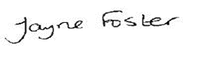
Jayne Foster
CEO, Ethos Academy Trust

HEADTEACHER WELCOME

Dear Applicant,

Reach Academy is a well-established pupil referral unit in Kirklees, specialising in supporting Key Stage 3 pupils with wide-ranging Social, Emotional and Mental Health (SEMH) needs.

At Reach Academy, we believe that all pupils deserve the opportunity to be supported to re-engage with learning and school life. We achieve this within a stimulating, safe and welcoming environment, where the curriculum is personalised to meet the differing needs and interests of all our pupils. Our staff pride themselves on offering a nurture-based approach and a high-quality educational provision that supports pupils to achieve positive outcomes and become ready to move onto further success in their next educational setting.

We are committed to ensuring that our staff are fully equipped to deliver a personalised, aspirational offer that meets the needs of all pupils. We therefore have a comprehensive staff training programme to enable our team to continue to develop their knowledge, skills and practice, with a high focus on supporting all aspects of SEMH needs.

Thank you for your interest in working at Reach Academy. Visits to the school are always welcome, so please do not hesitate to contact the main office for further information.

Hannah Lord
Head Teacher, Reach Academy

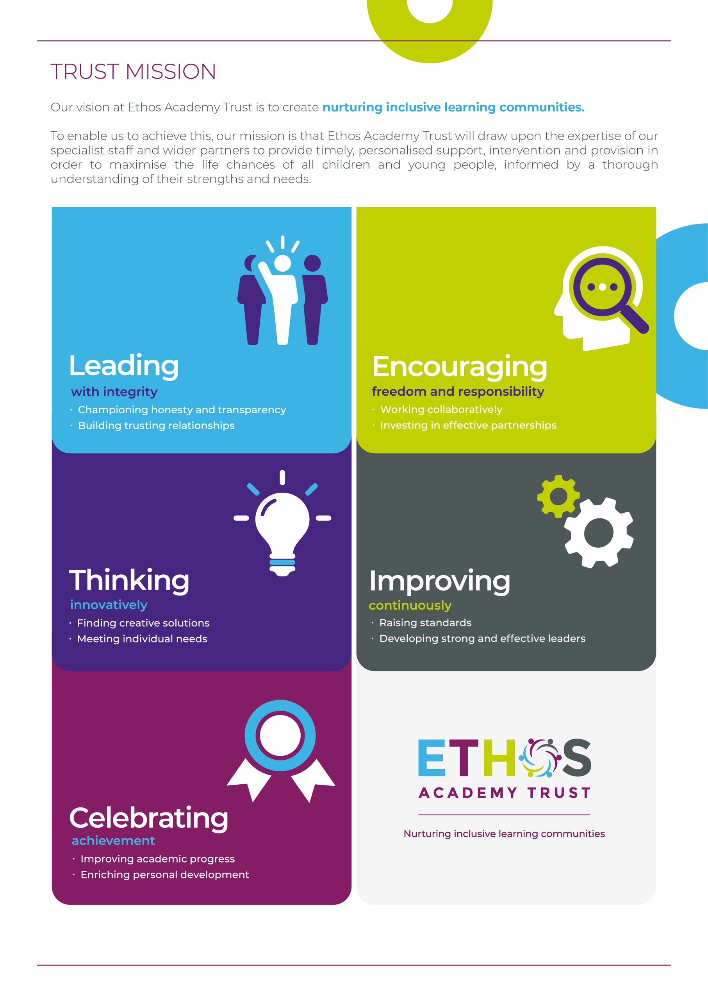

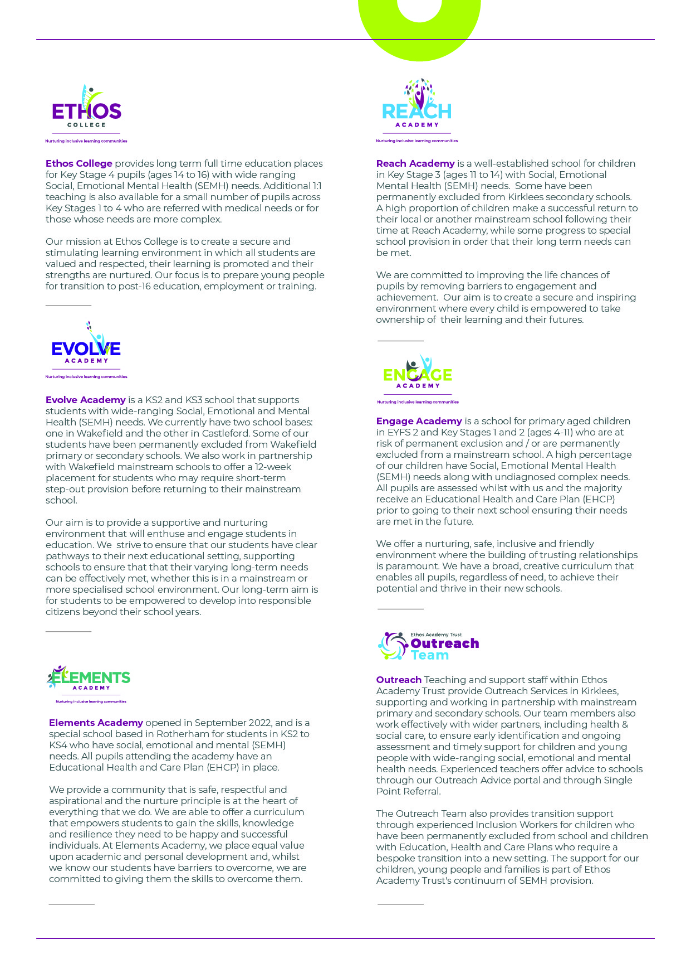

WHY WORK FOR THE TRUST?

Ethos Academy Trust is based in West Yorkshire, with all of our Academies in close proximity to one another and in easy reach of main motorways and the cities and towns of Leeds, Wakefield, Huddersfield, Bradford and Rotherham. The proximity of our Academies is such that it lends itself to close and collaborative working.

At Ethos Academy Trust, we are committed to providing a top-class education and we put the needs of all of the young people within our community at the heart of what we do. Our staff are pivotal in this and also in recognising, achieving and bringing to life our vision and values.

As such, we are committed to providing our staff with high quality professional development which can be evidenced through a variety of channels. We have numerous examples of staff who have developed and progressed their careers with the Trust. We fully embrace the fact that if we invest in our staff and their futures, we will create an environment where staff are happy, inspired and ambitious, which in turn means that they are able to create positive, engaging and life changing learning experiences for young people.

Ethos Academy Trust is fully committed to supporting and enhancing the wellbeing and mental health of all stakeholders. Across the Trust there are regular opportunities for staff to come together outside of their normal working day in a social or other activity capacity.

As an employer, we are able to provide the following benefits to all members of staff:

- The Trust maintains nationally agreed terms and conditions in relation to pay and conditions for teaching and support staff, and continues to subscribe to local holiday patterns and allowances within the local authority of each academy.
- All employees have the opportunity to access a pension scheme.
- All employees have access to Healthline which includes 24/7 Employee Assistance Programme and services such as physio and counselling for employees and their dependants
- An opportunity to collaborate with colleagues across academies and within the central Trust teams, with other academies and Multi Academy Trusts on a local or regional basis.
- Structured and informal opportunities to develop skills and opportunity to progress, share best practice (locally and nationally).
- Access to employee salary sacrifice schemes such as Cyclescheme, Techscheme and discounted gift cards.

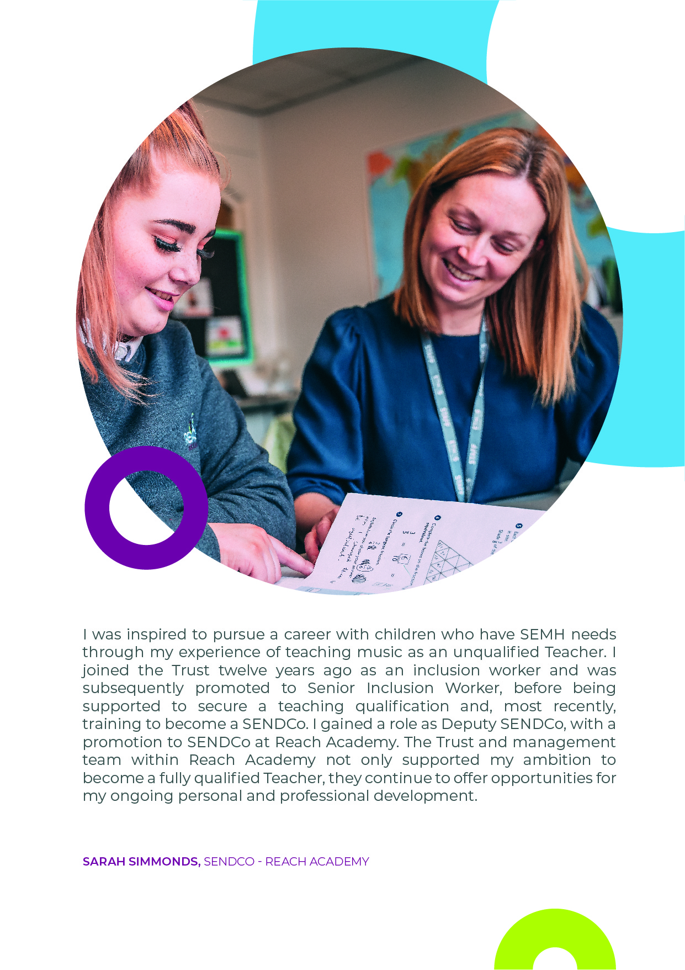

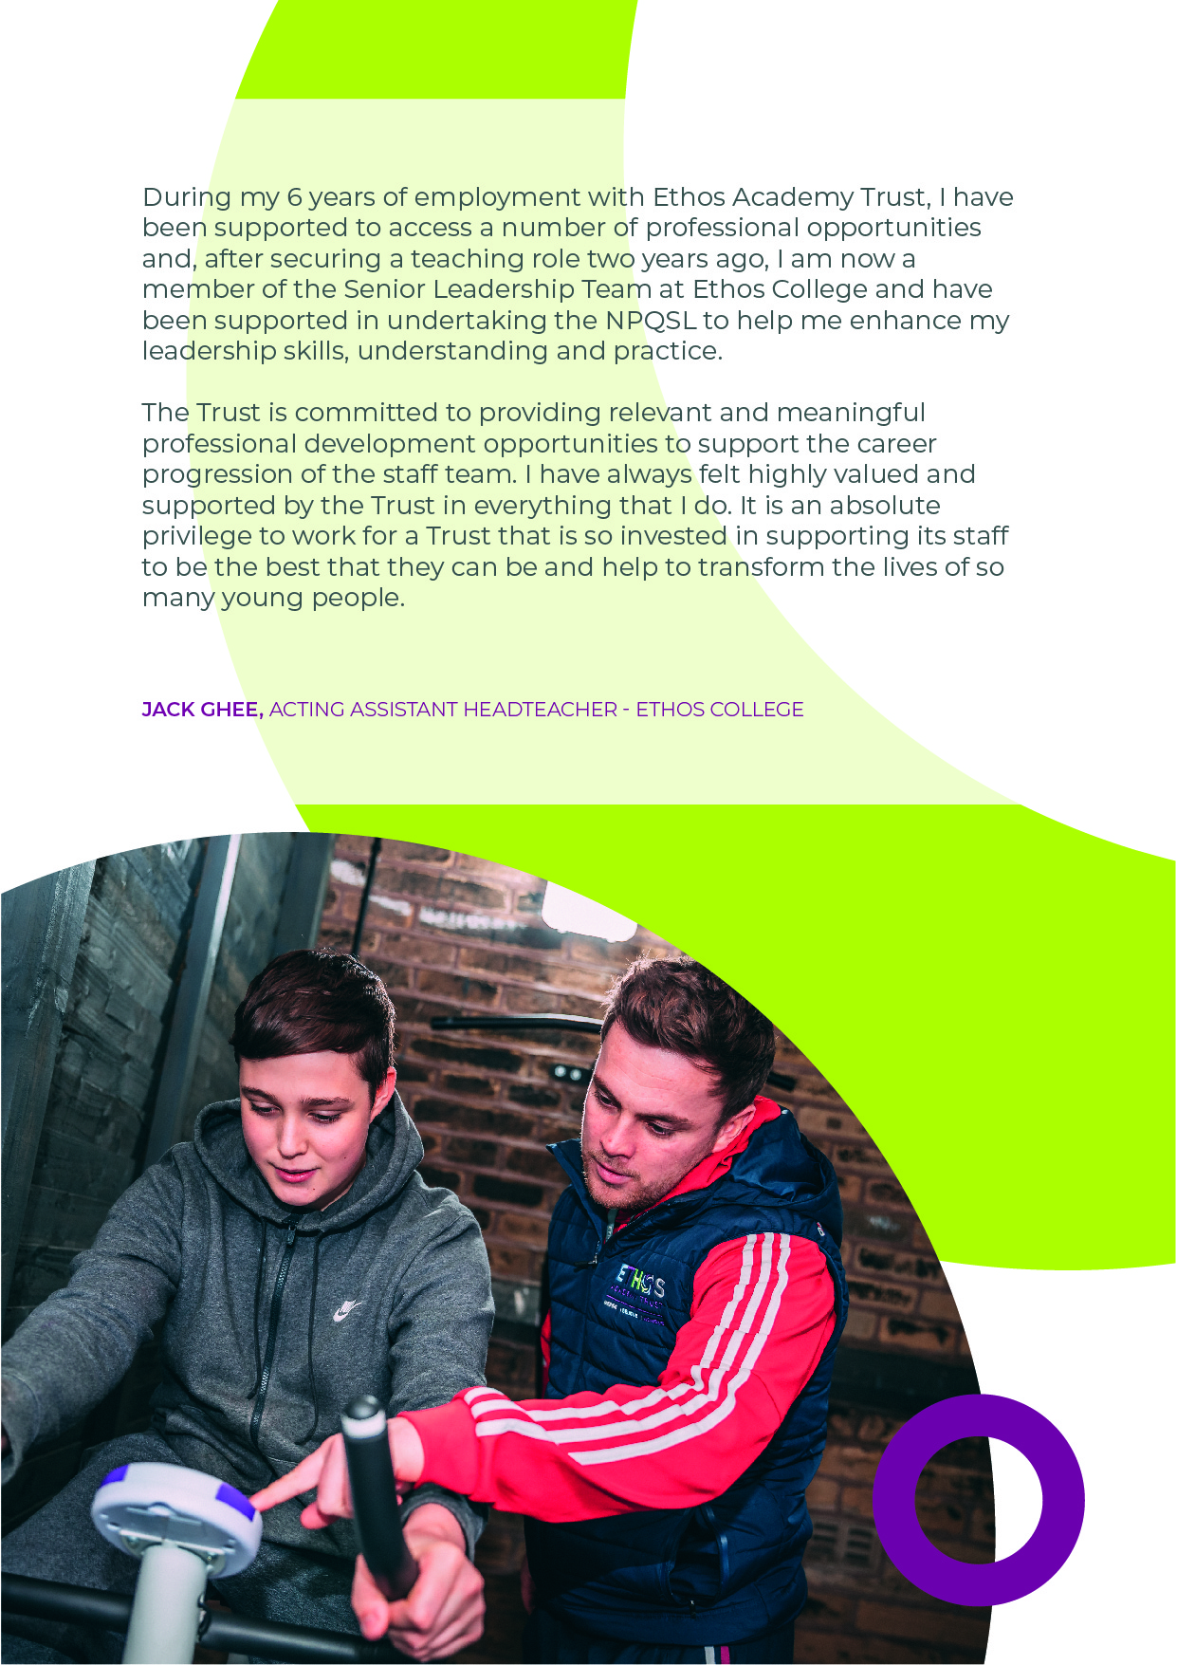

ADVERT FOR NURTURE TEACHER

Job Title: Nurture Teacher
Grade: MPS/UPS plus 2 SEN points
Hours –Full time
Permanent
Closing date: 20th February 2023 12pm
Interviews: 24th February 2023

About Ethos Academy Trust
Ethos Academy Trust is located within Kirklees and Wakefield, West Yorkshire and Rotherham, South Yorkshire. The overarching aim of the Trust is to create academies that provide environments that are welcoming, caring, calm, safe and purposeful and that, within a nurturing ethos, stretch our learners academically, support them pastorally and develop them socially and emotionally.

We seek to explore and celebrate the qualities that make our pupils unique. We believe passionately that education, at every stage of the pupil journey, is about the development and nurture of the whole child. We aspire for all our pupils to become confident, happy and caring individuals who achieve personal success and develop a love of learning and of life.

In addition to what will soon become six academies (Ethos College, Reach Academy, Engage Academy, Evolve Academy, Elements Academy and Enrich Academy), the Trust provides wide ranging early intervention outreach support and training to mainstream schools, alongside managing the statutory exclusions process on behalf of Kirklees and Wakefield Local Authorities.

Applicants
This is an exciting opportunity to join Ethos Academy Trust, where we aim to deliver the very best educational experiences for pupils from across the primary and secondary age range. Our academies are welcoming, calm and purposeful and, within a nurturing ethos, our learners are stretched academically, supported pastorally and developed socially and emotionally.

We are looking to appoint an inspirational Teacher to join our passionate and hardworking team at Reach Academy. Reach Academy is an Alternative Provision for Key Stage 3 pupils, working with pupils with social, emotional and mental health needs or other SEN needs.

We are ideally looking to recruit a primary practitioner or a teacher with experience of teaching in a nurture group. AN ability to teach maths, English and Science to lower KS3 is also an advantage. This post is suitable for primary or secondary teachers.

The role will be to successfully motivate, inspire and engage with vulnerable children and their families. You will develop an inspiring, nurturing classroom environment conductive for learning. You will be required to work collaboratively and in partnership with parents and carers, teaching and support staff in schools and other professionals in order to achieve the very best outcomes for the pupils.

If you are looking for a new and rewarding challenge in education, you are committed and passionate then we look forward to hearing from you.

Closing date: 20th February 2023 12pm
Interview date: 24th February 2023

We welcome and encourage visits to the academy from prospective candidates.

If you have any questions about the role or would like to arrange a visit, please contact Hannah Lord at reachoffice@eat.uk.com

You can apply for the vacancy at https://www.eat.uk.com/recruitment-portal/current-opportunities/

JOB DESCRIPTION

Job title | Nurture Teacher
Location | Reach Academy, Batley Field Hill, Batley, WF!7 0BQ
Hours | Full time, permanent
Reports to | Head Teacher
Staff responsible for | Inclusion Worker
Closing Date | 20th February 2023 12pm
Salary/Grade | MPS/UPS plus 2 SEN points
Job Purpose | You will lead a class group of pupils, planning and delivering outstanding lessons including maths, English and cross curricular learning opportunities, whilst securing a nurturing, supportive environment with high expectations for all pupils to enable them to achieve their potential.  You will take responsibility for the lead of a subject(s) across the academy, initially leading and teaching science.

KEY OBJECTIVES AND ACCOUNTABILITIES

Key Outcomes

As a Nurture Teacher you will:
- Develop an ambitious, personalised curriculum, for individuals and groups of pupils to re-engage them in learning, supporting individual learning pathways in response to SEMH needs and ensuring high quality outcomes.
- Effectively implement tracking and assessment processes to monitor, report and evaluate the effectiveness of the curriculum and its impact on pupil progress.
- Develop an inspiring nurturing classroom environment conducive to learning.
- Have pastoral responsibility for named pupils within the academy.
- Have responsibility for reporting pupil progress to schools, parents and agencies, through home reports, placement reports, SEN reports/plans and reintegration reports.
- Set individual targets (academic and personal/social), review and report on progress for all pupils.
- Use Boxall profiles (and other SEMH tools) to provide a clear assessment of pupils’ SEMH development needs and track their progress towards set targets.
- Liaise with colleagues to ensure high quality provision is delivered and best practice is shared across the Trust.
- Provide a stimulating, educational environment for specific groups of pupils with a range of needs.
- Develop a positive ethos that ensure a calm classroom environment through the effective implementation of the school’s communication and behaviour policy.
- Support pupils and staff in mainstream schools where necessary.
- Have responsibility for a designated subject area(s).
- Attend meetings as required by the Head Teacher.
- Advise schools with regard to the SEN Code of Practice where required.
- Contribute to the maintenance of up-to date records within the Trust.
- Support pupils and their parents/carers in enabling them to make the most of the educational opportunities offered by the Trust.
- Liaise with other agencies when appropriate i.e. Social Services, Educational Psychology, the Virtual School, CAHMS, SENDACT etc.

Main Duties

- To ensure the holistic development of pupils through developing and delivering provision of exceptional education every day.
- To develop and equip pupils with the outstanding character, social skills and moral compass to drive their own success and make a positive contribution to society.
- To prepare pupils for their next phase in their education through delivery of PSHCE, RSE and Careers to pupils within a group
- Ensure students cognitive and moral qualities and traits contribute to a person’s individuality and makes them different from others
- Keep abreast of developments in all areas of the National Curriculum, Special Educational Needs and teaching and learning.
- Participate in continuing professional development (CPD) and performance management in line with Trust policy and practice.
- Carry out any other duties, appropriate to the level reasonably expected of a teacher paid an equivalent SEN allowance, relating to the efficient organisation of the service.
- Take reasonable care of the health and safety of self, other persons and resources whilst at work.
- Co-operate with management of the Trust as far as is necessary to enable the responsibilities placed up on the Trust under Health and Safety at Work to be performed e.g. operate safe working practices.
- Carry out professional duties of a teacher outlined in the most recent Teacher’s Pay and Conditions document, including Teachers Professional Standards, as directed by the Head Teacher.
- Research, prepare and select teaching resources that meet the diversity of pupils’ needs and interests.
- Effectively use Information Communication Technology (ICT) to enhance learning activities and increase pupils’ competence and confidence.
- Adhere to the Trust’s policies and ensure they are applied consistently.
General
- Be aware of and support difference and ensure equal opportunities for all.
- Contribute to the overall ethos/work/aims of the Trust.
- Attend meetings within the Trust, at its academies and external events as required.
- Share expertise and skills with others.
- Participate in training and other learning activities and performance development as required.
- Work effectively and professionally with all stakeholders, promoting the Trust positively at all times.
- Recognise own strengths and areas of expertise and use these to advise and support colleagues.
- Maintain confidentiality always in respect of school-related matters and to prevent disclosure of confidential and sensitive information.
- Ensure strict confidentiality in all areas of work.
- All employees are required to uphold the values of democracy, rule of law, individual liberty and tolerance and have mutual respect for those with different faiths and beliefs (Prevent).
- Work and process personal and sensitive information in accordance with Data Protection Act 2018 including the General Data Protection Regulations (GDPR) 2018.
- Understand and comply with the statutory guidance regarding safeguarding of children, ensuring the safeguarding and promotion of children’s welfare at all times, reporting any concerns to the Designated Safeguarding Lead immediately.
PERSON SPECIFICATION

 | Key Criteria | Essential (E) / Desirable (D)
Knowledge, Education and Training | Hold qualified teacher status | E
 | Have evidence of recent, relevant CPD | E
 | Willingness to lead CPD sessions for staff | E
 | Evidence of nationally recognised nurture-based training/qualifications | D
Relevant Experience | Knowledge of nurturing principles and how they can be applied to develop and deliver outstanding practice within a nurture-based setting | E
 | Evident understanding and application of quality first teaching in a primary and/or secondary setting | E
 | A proven track record of raising attainment and relevant strategies | E
 | Experience of managing and using pupil attainment and tracking data | E
 | Experience of initiating and implementing strategies to improve parental involvement in their children’s learning | E
 | Experience of working with pupils with social, emotional and mental health difficulties either in mainstream or special schools | E
 | Experience of liaison and co-operation with other professional agencies. | E
 | Experience of motivating hard to reach learners | E
 | Experience of establishing nurture settings | D
Aptitudes, skills and competencies | Proven track record as an outstanding classroom practitioner | E
 | Ability to articulate a clear vision for high quality teaching and learning | E
 | Have good communication skills and a positive outlook | E
 | Ability to develop and maintain effective professional relationships with all members of the school community and outside agencies | E
 | Emotional resilience in working with pupils with exhibit challenging behaviour | E
 | Be able to work under pressure and prioritise to meet deadlines | E
 | Ability to travel to different areas within Kirklees | E
Any additional factors | The post holder may be required to work outside of normal school hours on occasion with due notice | E
 | Willingness to be flexible and adaptable in a variety of situations | E
 | Willingness to undergo an enhanced DBS check and sign up to the DBS service on an annual basis | E
 | Commitment to ongoing personal training and development | E
 | Willingness to work offsite with pupils and families | E
 | Full driving licence and willingness to transport pupils on own vehicle and obtain business insurance | E
 | Understanding of relevant policies/codes of practice and awareness of relevant legislation | E

Safeguarding statement
Ethos Academy Trust is committed to safeguarding and promoting the welfare of children and applicants must be willing to undergo child protection screening appropriate to the post, including an Enhanced DBS check (including Children’s Barred List) and past employment references.

Applicants are required, before appointment to disclose any conviction, caution or binding over including ‘spent convictions’ under the Rehabilitation of Offenders Act 1974 (Exemptions) Order 1975.

Equality and Diversity statement
Ethos Academy Trust treats all applicants for employment in the same way regardless of age, disability, gender reassignment, marriage and civil partnership, pregnancy and maternity, race, religion or belief, sex or sexual orientation.

Disability statement
Ethos Academy Trust is committed to promoting equality of opportunity for people with disabilities. We continue to review our processes and procedures to ensure individuals with disabilities receive full and fair consideration for all types of vacancies at the recruitment stage and during their employment.

Individuals who apply to the Trust for employment will receive fair treatment and be considered solely on their ability to do the job. Where required reasonable adjustments will be applied. During employment the Trust, wherever possible, will retain the services of an employee who is or has become disabled.

Online checks for shortlisted candidates
In accordance with DfE Keeping Children Safe in Education 2022, an online search, including social media, will be completed on all shortlisted applicants prior to interview. Any relevant information will be discussed further with the applicant during the recruitment process.

GDPR
A copy of our Privacy Notice is available via our website: www.eat.co.uk

